 **SAVEETHA SCHOOL OF ENGINEERING**

SAVEETHA INSTITUTE OF MEDICAL AND TECHNICAL SCIENCES

# DEPARTMENT OF COMPUTER SCIENCE AND ENGINEERING

LAB MANUAL CSA15

CLOUD COMPUTING AND BIG DATA ANALYTICS

**SAVEETHA SCHOOL OF ENGINEERING**

SAVEETHA INSTITUTE OF MEDICAL AND TECHNICAL SCIENCES **DEPARTMENT OF COMPUTER SCIENCE AND ENGINEERING**

**CSE DEPARTMENT VISION-MISSION**

# Vision of the Department

To establish an environment to provide quality education and Inculcate research attributes among computer science engineering graduates through problem solving skills and technological innovations.

# Mission of the Department

**M1**

To create and sustain an academic environment to the highest level in teaching and research by enhancing the knowledge of the faculties and students in technological advancements to solve real time problems.

# M2

Providing a suitable environment for the students to develop professionalism with knowledge in Computer Science & Engineering to meet the contemporary industry needs and satisfy global standards.

# M3

To facilitate the development of professional behaviour and stronger ethical values so as to work with commitment for the progress of the nation and face challenges with ethical and social responsibility.

**Course Outcomes (CO)**

|  |  |  |
| --- | --- | --- |
| CO7 | Able to show resource provisioning in the cloud services using VMware workstation and CSP | PO5 |
| CO8 | Ability to use the Hadoop Distributed File Systems using Hadoop. | PO5 |
| CO9 | Ability to identify suitable Cloud deployment services and BigData analytics to find solutions to real time problems. | PO10 |
| CO10 | Ability to identify the solution for real time applications using Cloud and Big Data Analytics | PO10 |

**INSTRUCTIONS FOR THE EXPERIMENTS**

1. Students are advised to come to the laboratory on time; those who come after 5 minutes will not be

allowed into the lab.

1. Plan your task properly much before to the commencement, come prepared to the lab with the

synopsis / program / experiment details. Student should enter into the laboratory with:

* + Laboratory observation notes with all the details (Problem statement, Aim, Implementation, Steps, Program, Expected Output, etc.,) filled in for the lab session.
  + Laboratory Record updated up to the last session experiments and other utensils (if any) neededin the lab.
  + Proper Dress code and Identity card.
  + Sign in the laboratory login register, write the TIME-IN, and occupy the computer system allotted to you by the faculty.
  + Execute your task in the laboratory, and record the results / output in the lab observation note book, and get certified by the concerned faculty.
  + All the students should be polite and cooperative with the laboratory staff, must maintain the discipline and decency in the laboratory.
  + Computer labs are established with sophisticated and high-end branded systems, which should be utilized properly.
  + Students / Faculty must keep their mobile phones in SWITCHED OFF mode during the lab sessions. Misuse of the equipment, misbehaviors with the staff and systems etc., will attract severe punishment.
  + Students must take the permission of the faculty in case of any urgency to go out; if anybody found loitering outside the lab / class without permission during working hours will be treated seriously and punished appropriately.
  + Students should LOG OFF/ SHUT DOWN the computer system before he/she leaves the lab after completing the task (experiment) in all aspects. He/she must ensure the system / seat is kept properly.

**SAVEETHA SCHOOL OF ENGINEERING**

SAVEETHA INSTITUTE OF MEDICAL AND TECHNICAL SCIENCES

# DEPARTMENT OF COMPUTER SCIENCE AND ENGINEERING

**DO’S AND DON’TS**

* Be on time to lab and maintain silence.
* Inform the instructor /TA in case of any working environment problem.
* Be aware of all the safety devices. Even through the instructor and TA will take care of emergencies.
* Bring all the necessary things required to do laboratory experiments like observation notebook, record notebook and any others.
* Enter the system number, in-time, out-time register number, name and signature in the students log register.
* Arrange the seating chairs and system accessories in place at the end of the session.
* Shut down the system properly and switch off the power switch at the end of the session.
* Keep your bags in front of the labs empty space.
* Do not eat, drink, chew gum, smoke or apply cosmetics in the lab.
* Do not unplug/plug any wires of the system connectivity.
* Do not use or charge the mobile phone or any electronic gadgets inside the lab.
* Not to troubleshoot by yourself without knowledge of instructor/TA.
* Do not open any unnecessary applications in system.
* Mobiles phones are prohibited inside the lab.
* Do not share a system to do experiments.

# Students strictly follow all the above instructions

|  |  |  |  |  |  |
| --- | --- | --- | --- | --- | --- |
| **SAVEETHA SCHOOL OF ENGINEERIING DEPARTMENT OF COMPUTER SCIENCE AND ENGINEERING**  **CSA15 – CLOUD COMPUTING AND BIG DATA ANALYTICS LABORATORY**  **LIST OF EXPERIMENTS** | | | | | |
|  | **SNO** | **EXPERIMENT NAME** | **Blooms Taxonomy** | **CO** | **PO** |
| 1. | Create a simple cloud software application and provide it as a service using any Cloud Service Provider to demonstrate Software as a Service  (SaaS). | K03, K04 | CO7 | PO5 |
| 2. | Create a simple cloud software application for Flight Reservation System using any Cloud Service  Provider to demonstrate SaaS | K03, K04 | CO7 | PO5 |
| 3. | Create a simple cloud software application for  Property Buying & Rental process (In Chennai city) using any Cloud Service Provider to demonstrate  SaaS | K03, K04 | CO7 | PO5 |
| 4. | Create a simple cloud software application for Car Booking Reservation System using any Cloud  Service Provider to demonstrate SaaS. | K03, K04 | CO7 | PO5 |
| 5. | Create a simple cloud software application for Library book reservation system for SIMATS library using any Cloud Service Provider to demonstrate  SaaS | K03, K04 | CO7 | PO5 |
| 6. | Create a simple cloud software application for product selling using any cloud service provider to  demonstrate saas. | K03, K04 | CO7 | PO5 |
| 7. | Demonstrate virtualization by Installing Type-2  Hypervisor in your device, create and configure VM image with a Host Operating system (Either  Windows/Linux). | K03, K04 | CO7 | PO5 |
|  | | | | | |

|  |  |  |  |  |  |
| --- | --- | --- | --- | --- | --- |
|  | | | | | |
|  | 8. | Create a Virtual Machine with 1 CPU, 2GB RAM and 15GB storage disk using a Type 2 Virtualization  Software. | K03, K04 | CO7 | PO5 |
| 9. | Create a Virtual Hard Disk and allocate the storage  using VM ware Workstation | K03, K04 | CO7 | PO5 |
| 10. | Create a Snapshot of a VM and Test it by loading  the Previous Version/Cloned VM | K03, K04 | CO7 | PO5 |
| 11. | Create a Cloning of a VM and Test it by loading the  Previous Version/Cloned VM | K03, K04 | CO7 | PO5 |
| 12. | Change Hardware compatibility of a VM (Either by clone/create new one) which is already created  and configured. | K03, K04 | CO7 | PO5 |
| 13. | Demonstrate Infrastructure as a Service (IaaS) by creating a resources group using a Public Cloud  Service Provider (Azure), configure with minimum  CPU, RAM, and Storage. | K03, K04 | CO7 | PO5 |
| 14. | Demonstrate Infrastructure as a Service (IaaS) by creating a Virtual Machine using a Public Cloud  Service Provider (Azure), configure with required  memory and CPU. | K03, K04 | CO7 | PO5 |
| 15. | Demonstrate Infrastructure as a Service (IaaS) by establishing the remote connection, launch the  created VM image and run in your desktop. | K03, K04 | CO7 | PO5 |
| 16. | Demonstrate Platform as a Service (PaaS) create and configure a new VM Image in any Public Cloud  Service Provider | K03, K04 | CO7 | PO5 |
| 17. | Create a Simple Web Application using Java or Python and host it in any Public Cloud Service  Provider (Azure/GCP/AWS) to demonstrate Platform  as a Service (PaaS). | K03, K04 | CO7 | PO5 |
| 18. | Demonstrate Storage as a Service (SaaS) create and configure a new VM Image in any Public Cloud  Service Provider | K03, K04 | CO7 | PO5 |
| 19. | Create a Storage service using any Public Cloud  Service Provider (Azure/GCP/AWS) and check the public accessibility of the stored file to demonstrate  Storage as a Service. | K03, K04 | CO7 | PO5 |
| 20. | Database as a Service (DaaS) create and configure a  new VM Image in any Public Cloud Service Provider | K03, K04 | CO7 | PO5 |
| 21. | Create a SQL storage service and perform a basic query using any Public Cloud Service Provider (Azure/GCP/AWS) to demonstrate Database as a  Service (DaaS) | K03, K04 | CO8 | PO5 |

|  |  |  |  |  |  |
| --- | --- | --- | --- | --- | --- |
|  | | | | | |
|  | 22. | Perform the basic configuration setup for installing HADOOP 2.x like creating the HDUSER and SSH  localhost | K03, K04 | CO8 | PO5 |
| 23. | Install Hadoop 2.x and configure the Name Node  and Data Node. | K03, K04 | CO8 | PO5 |
| 24. | Launch the Hadoop 2.x and test the Map-Reduce  Platform with Hadoop. | K03, K04 | CO8 | PO5 |
| 25. | Launch the Hadoop 2.x and perform Map-Reduce  program For a word count problem | K03, K04 | CO8 | PO5 |
|  | | | | | |

EXP NO 1: CREATE A SIMPLE CLOUD SOFTWARE APPLICATION AND PROVIDE IT AS A SERVICE USING ANY CLOUD SERVICE PROVIDER TODEMONSTRATE SOFTWARE AS A SERVICE (SAAS).

DATE:

AIM:

To create a simple cloud software application and provide it as a service using any cloud service provider todemonstrate software as a service (saas).

PROCEDURE:

**STEP1:** GOTO ZOHO.COM

**STEP 2:** LOGIN TO THE ZOHO.COM **STEP 3:** SELECT ONE APPLICATION **STEP 4:** ENTER APPLICATION NAME

**STEP 5:** CREATED NEW APPLICATION

**STEP 6:** SELECT ONE FORM

**STEP 7:** THE SOFTWARE HASE BEEN CREATED.

IMPLEMENTATION:

STEP1: GOTO ZOHO.COM

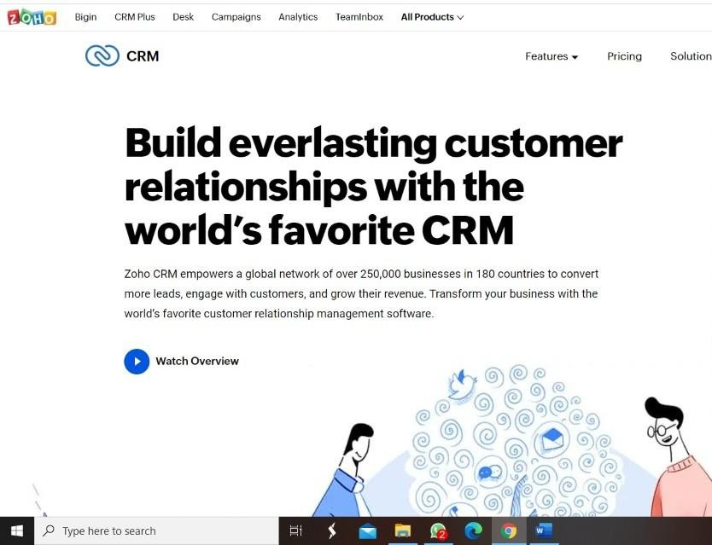

STEP 2: LOGINTOTHE ZOHO.COM



STEP 3: SELECT ONE APPLICATION

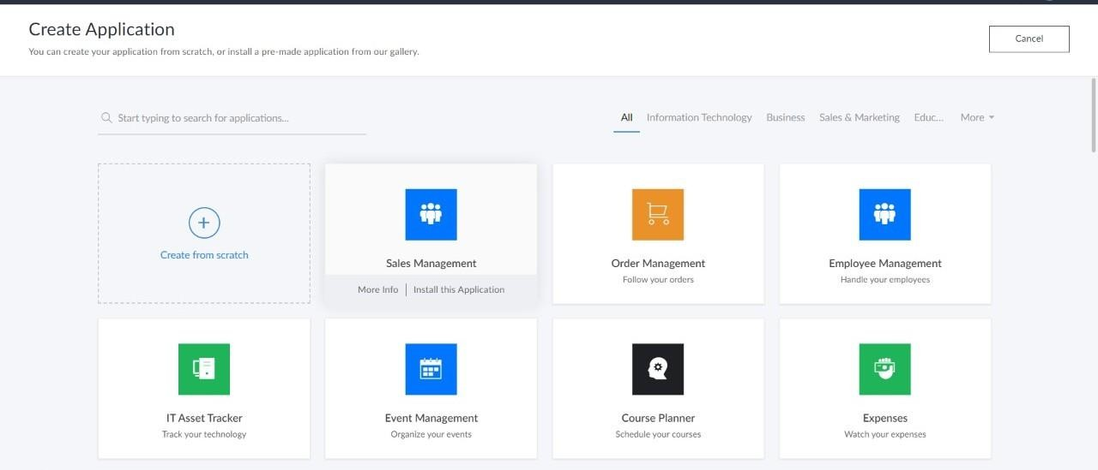

STEP 4: ENTER APPLICATION NAME

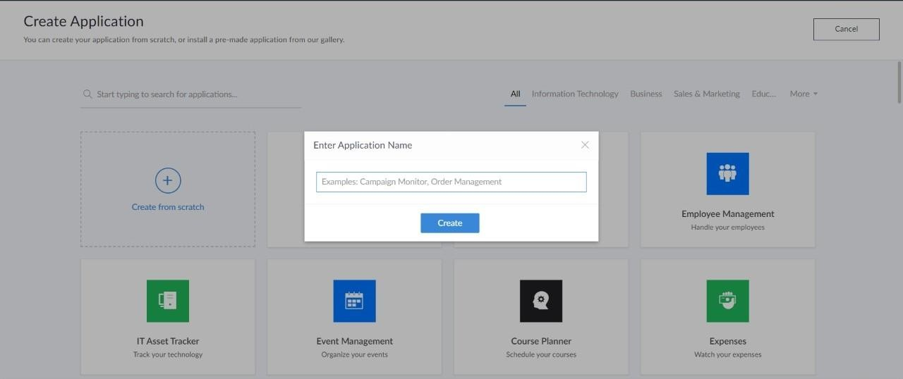

STEP 5: CREATED NEW APPLICATION

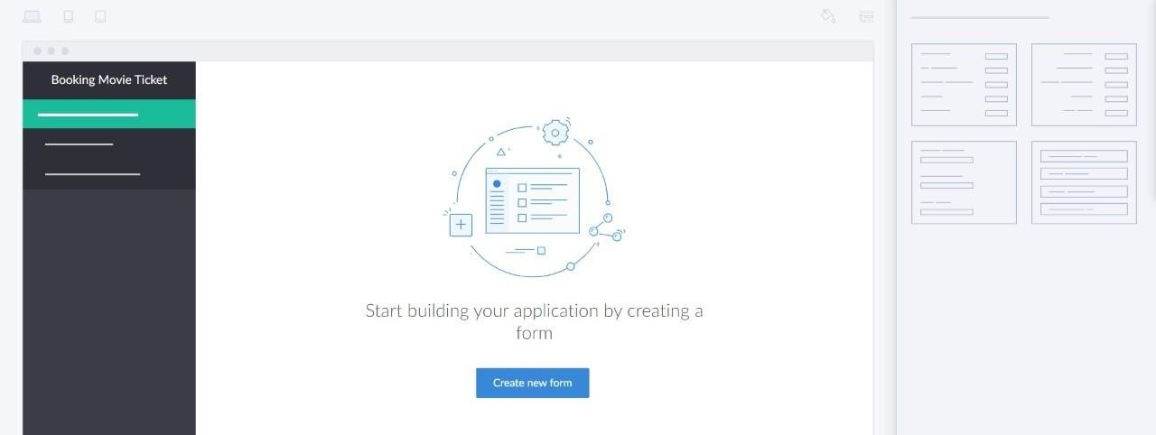

STEP 6: SELECT ONE FORM

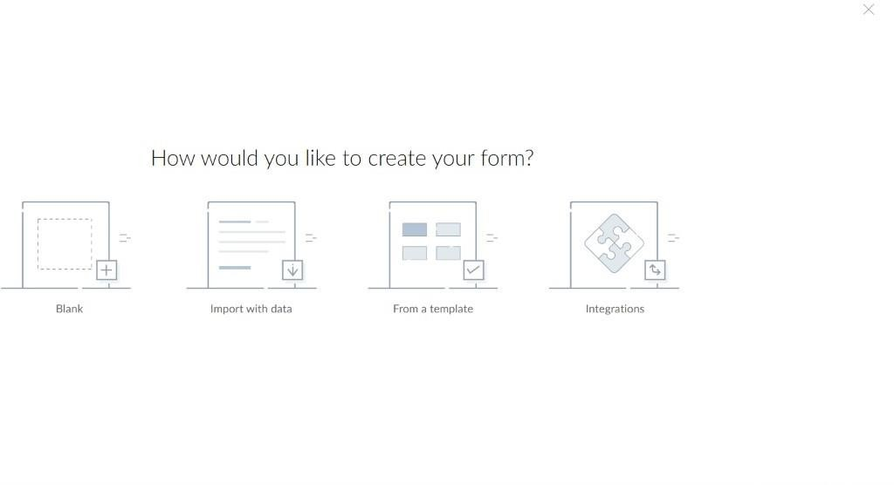

STEP 7: THE SOFTWARE HASE BEEN CREATED.

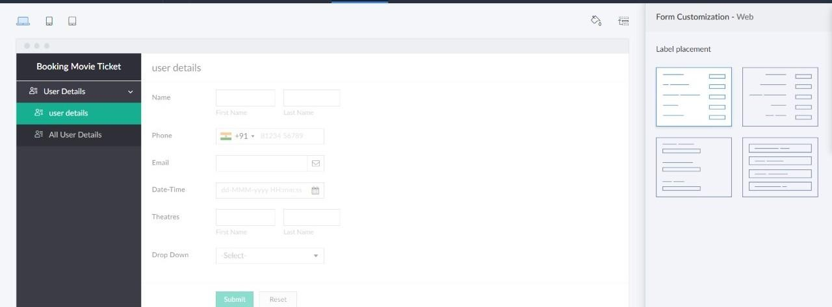

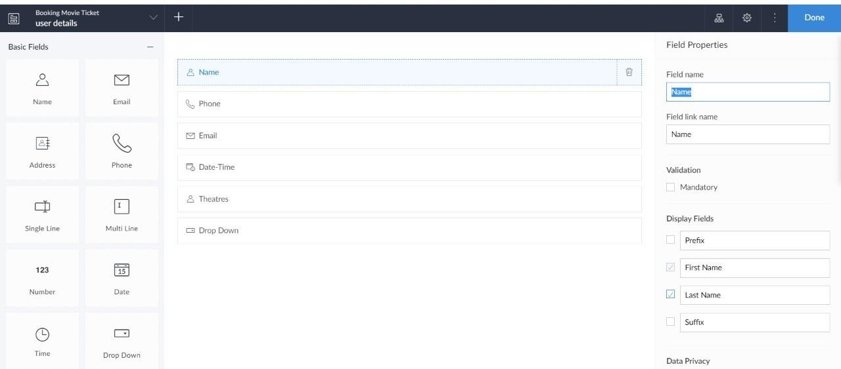

# EXP NO 2: CREATE A SIMPLE CLOUD SOFTWARE APPLICATION FOR FLIGHT RESERVATION SYSTEM USING ANY CLOUD SERVICE PROVIDER TO DEMONSTRATE SAAS.

DATE: AIM:

To create a simple cloud software application for flight reservation system using

any cloud service provider to demonstrate saas.

PROCEDURE:

**step1:** Go to zoho.com.

**step 2:** Log into the zoho.com.

**step 3:** Select one application step.

**step4:** Enter application name as flight reservation system. **step 5:** Created new application flight reservation system. **step 6:** Select one form

**step 7:** The software has been created.

IMPLEMENTATION:

STEP1: GOTO ZOHO.COM



STEP 2: LOGINTOTHE ZOHO.COM



STEP 3: SELECT ONE APPLICATION



STEP 4: ENTER APPLICATION NAME



STEP 5: CREATED NEW APPLICATION



STEP 6: SELECT ONE FORM



STEP 7: THE SOFTWARE HASE BEEN CREATED.





# EXP NO 3: CREATE A SIMPLE CLOUD SOFTWARE APPLICATION FOR PROPERTY BUYING & RENTAL PROCESS (IN CHENNAI CITY) USING ANY CLOUD SERVICE PROVIDER TO

**DEMONSTRATE SAAS.**

DATE:

AIM:

To Create a simple cloud software application for Property Buying & Rental process (In Chennai city) using any Cloud Service Provider to demonstrate SaaS.

PROCEDURE:

**step1:** Go to zoho.com.

**step 2:** Log into the zoho.com.

**step 3:** Select one application step.

**step4:** Enter application name as property buying & rental. **step 5:** Created new application as property buying & rental. **step 6:** Select one form

**step 7:** The software has been created.

IMPLEMENTATION:

STEP1: GOTO ZOHO.COM



STEP 2: LOGINTOTHE ZOHO.COM



STEP 3: SELECT ONE APPLICATION



STEP 4: ENTER APPLICATION NAME



STEP 5: CREATED NEW APPLICATION



STEP 6: SELECT ONE FORM



STEP 7: THE SOFTWARE HASE BEEN CREATED.





# EXP NO 4: CREATE A SIMPLE CLOUD SOFTWARE APPLICATION FOR CAR BOOKING RESERVATION SYSTEM USING ANY CLOUD SERVICE PROVIDER TO DEMONSTRATE SAAS.

DATE:

AIM:

To Create a simple cloud software application for Car Booking Reservation System using any Cloud Service Provider to demonstrate SaaS.

PROCEDURE:

**step1:** Go to zoho.com.

**step 2:** Log into the zoho.com.

**step 3:** Select one application step.

**step4:** Enter application name as Car Booking Reservation System. **step 5:** Created new application as Car Booking Reservation System. **step 6:** Select one form

**step 7:** The software has been created.

IMPLEMENTATION:

STEP1: GOTO ZOHO.COM



STEP 2: LOGINTOTHE ZOHO.COM



STEP 3: SELECT ONE APPLICATION



STEP 4: ENTER APPLICATION NAME



STEP 5: CREATED NEW APPLICATION



STEP 6: SELECT ONE FORM



STEP 7: THE SOFTWARE HASE BEEN CREATED.





# EXP NO 5: CREATE A SIMPLE CLOUD SOFTWARE APPLICATION FOR LIBRARY BOOK RESERVATION SYSTEM FOR SIMATS LIBRARY USING ANY CLOUD SERVICE PROVIDER TO DEMONSTRATE SAAS

DATE:

AIM:

To Create a simple cloud software application for Library book reservation system for SIMATS library using any Cloud Service Provider to demonstrate SaaS

PROCEDURE:

**step1:** Go to zoho.com.

**step 2:** Log into the zoho.com.

**step 3:** Select one application step.

**step4:** Enter application name as library book reservation system. **step 5:** Created new application as library book reservation system. **step 6:** Select one form

**step 7:** The software has been created.

IMPLEMENTATION:

STEP1: GOTO ZOHO.COM



STEP 2: LOGIN TO THE ZOHO.COM



STEP 3: SELECT ONE APPLICATION



STEP 4: ENTER APPLICATION NAME



STEP 5: CREATED NEW APPLICATION



STEP 6: SELECT ONE FORM



STEP 7: THE SOFTWARE HASE BEEN CREATED.





# EXP NO 6: CREATE A SIMPLE CLOUD SOFTWARE APPLICATION FOR PRODUCT SELLING USING ANY CLOUD SERVICE PROVIDER TO DEMONSTRATE SAAS.

DATE:

AIM:

To create a simple cloud software application for product selling using any cloud service provider to demonstrate saas.

PROCEDURE:

**step1:** Go to zoho.com.

**step 2:** Log into the zoho.com.

**step 3:** Select one application step.

**step4:** Enter application name as product selling. **step 5:** Created new application as product selling. **step 6:** Select one form

**step 7:** The software has been created.

IMPLEMENTATION:

STEP1: GOTO ZOHO.COM



STEP 2: LOGIN TO THE ZOHO.COM



STEP 3: SELECT ONE APPLICATION



STEP 4: ENTER APPLICATION NAME



STEP 5: CREATED NEW APPLICATION



STEP 6: SELECT ONE FORM



STEP 7: THE SOFTWARE HASE BEEN CREATED.





# EXP NO 7: DEMONSTRATE VIRTUALIZATION BY INSTALLING TYPE-2 HYPERVISOR IN YOUR DEVICE, CREATE AND CONFIGURE VM IMAGE WITH A HOST OPERATING SYSTEM (EITHER WINDOWS/LINUX).

**DATE:**

**AIM:**

To demonstrate virtualization by installing type-2 hypervisor in your device, create and configure VM image with a host operating system (either windows/linux).

**PROCEDURE:**

**STEP 1:**Dowload VMware workstation and installed as type 2hypervisor.

**STEP2:**Dowload ubuntu or tiny OS as iso image file. **STEP 3:** In VMware workstation->create new VM. **STEP 4:** Do the basic configuration settings.

**STEP 5:** Created tiny OS virtual machine. **STEP 6:** Launch the VM. IMPLEMENTATION:

STEP 1:DOWLOAD VMWARE WORKSTATION AND INSTALLED AS TYPE 2HYPERVISOR

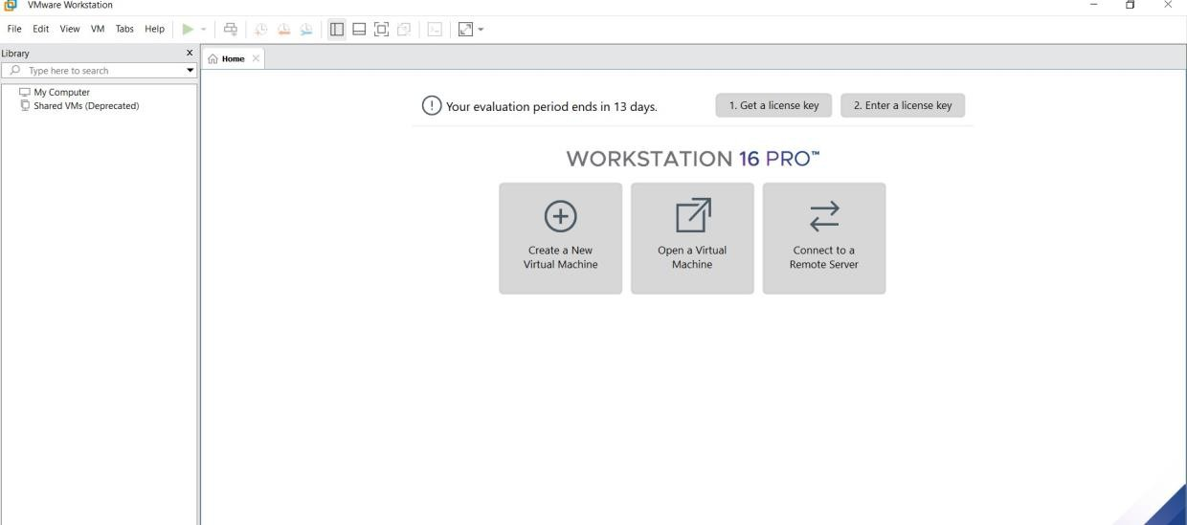

STEP2: DOWLOAD UBUNTU OR TINY OS AS ISO IMAGE FILE

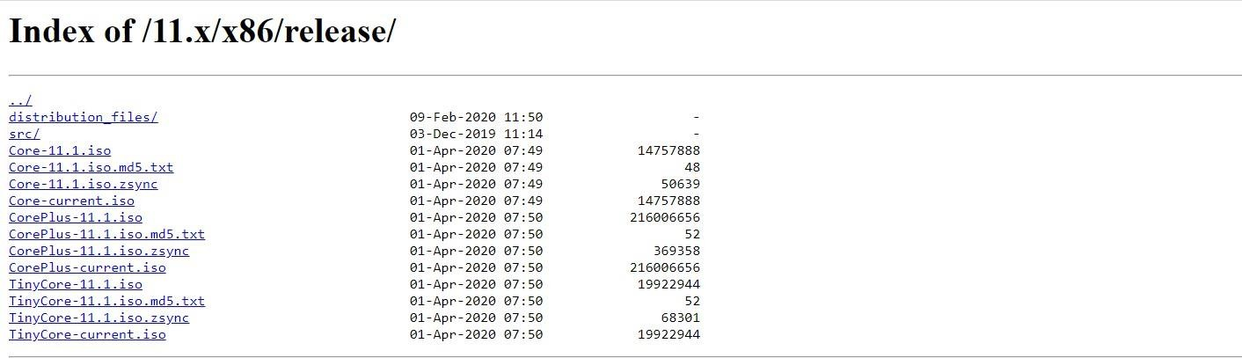

STEP 3: IN VMWARE WORKSTATION->CREATE NEW VM

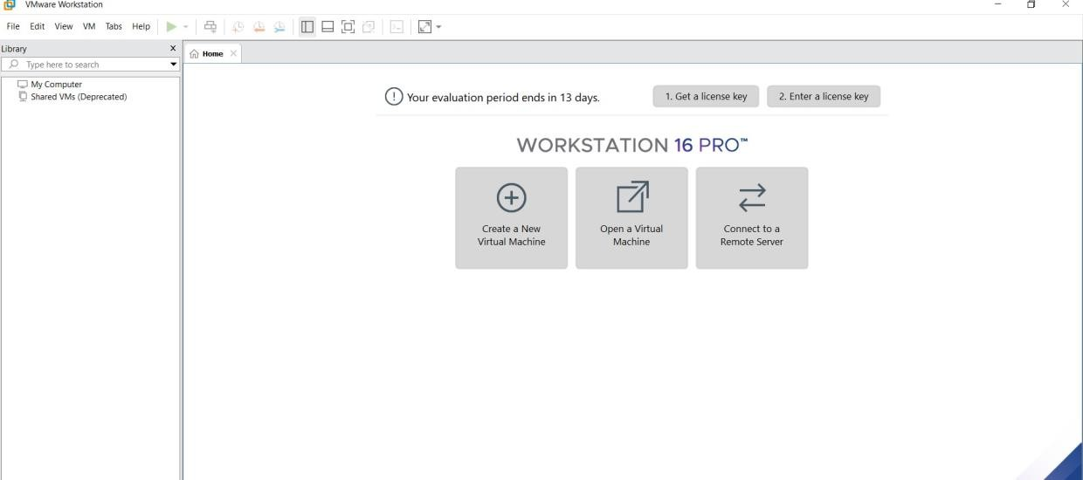

STEP 4: DO THE BASIC CONFIGURATION SETTINGS.

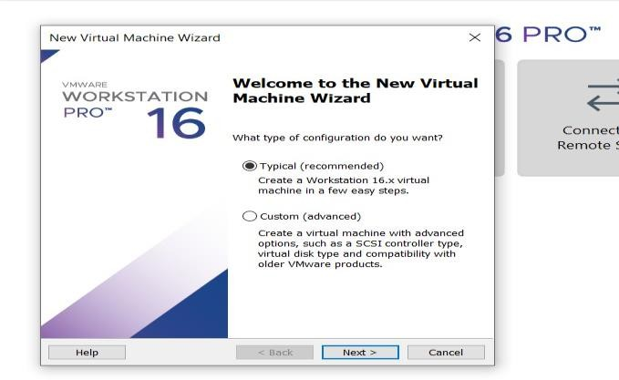

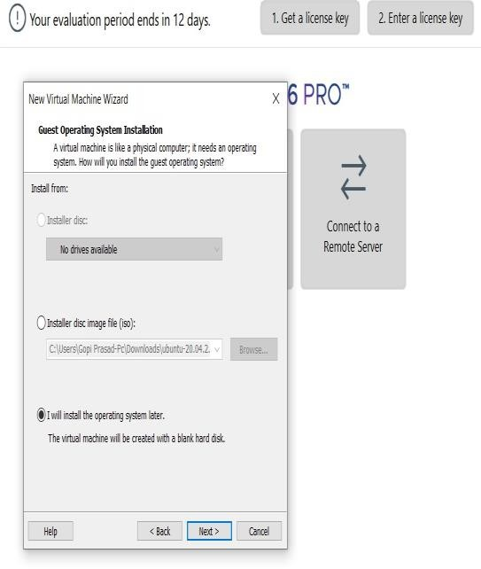

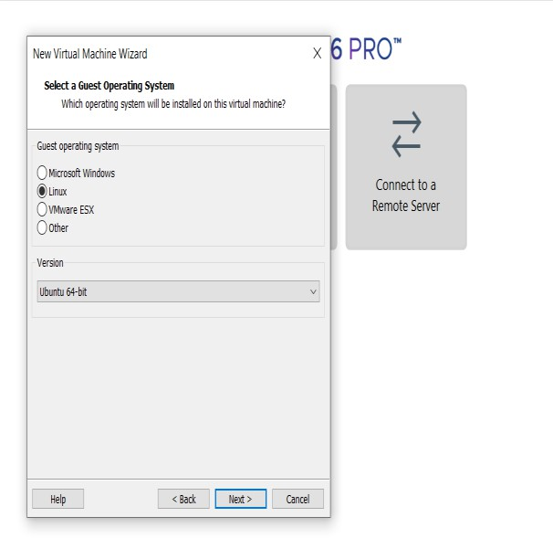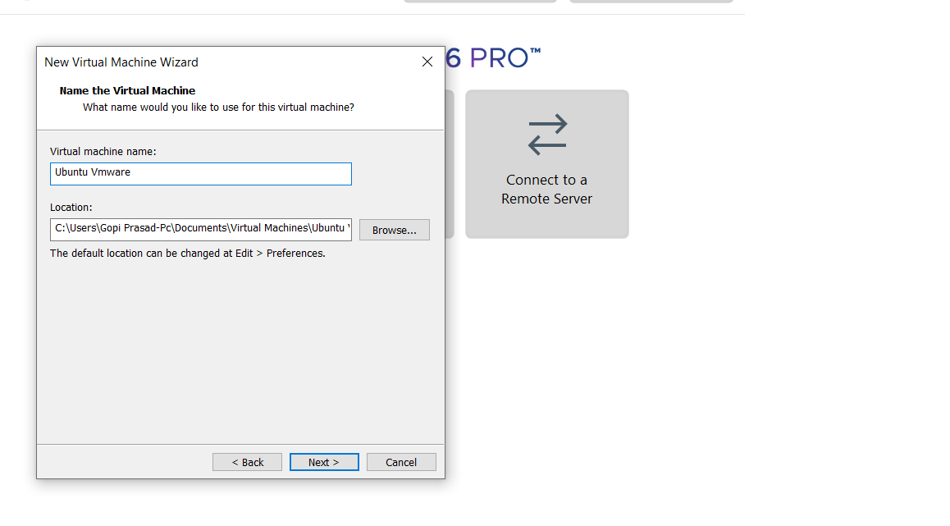

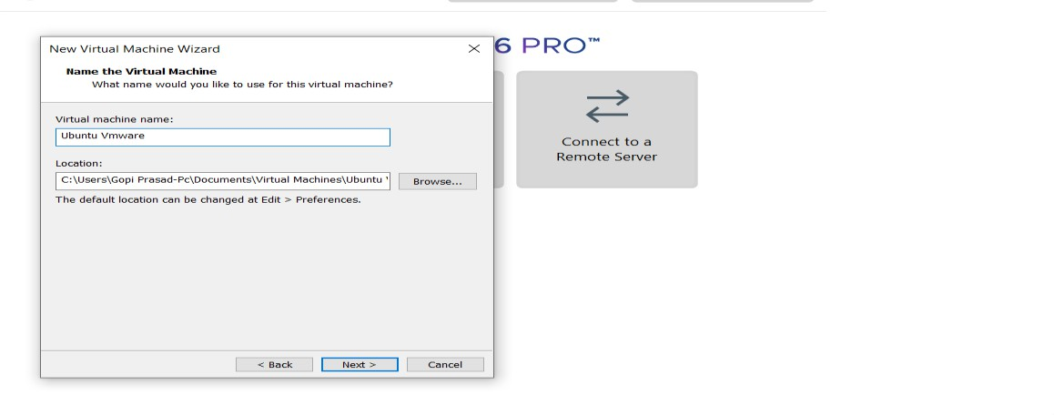

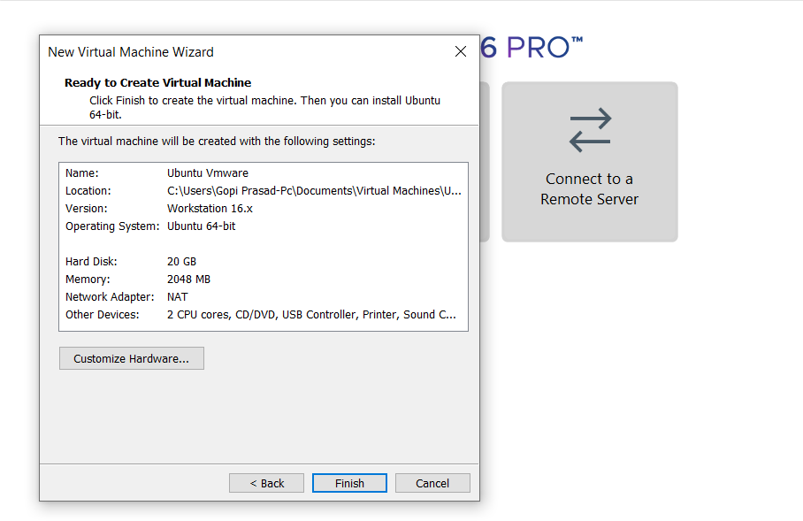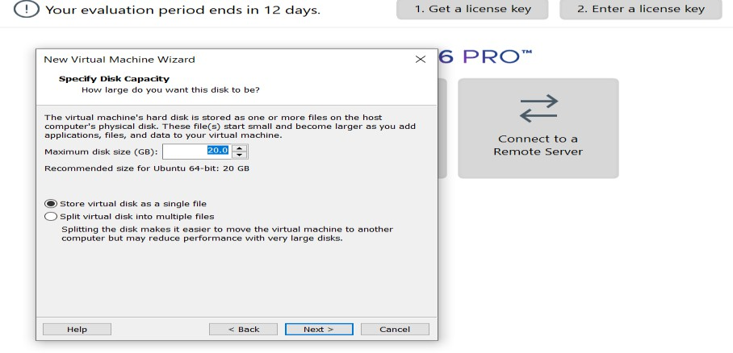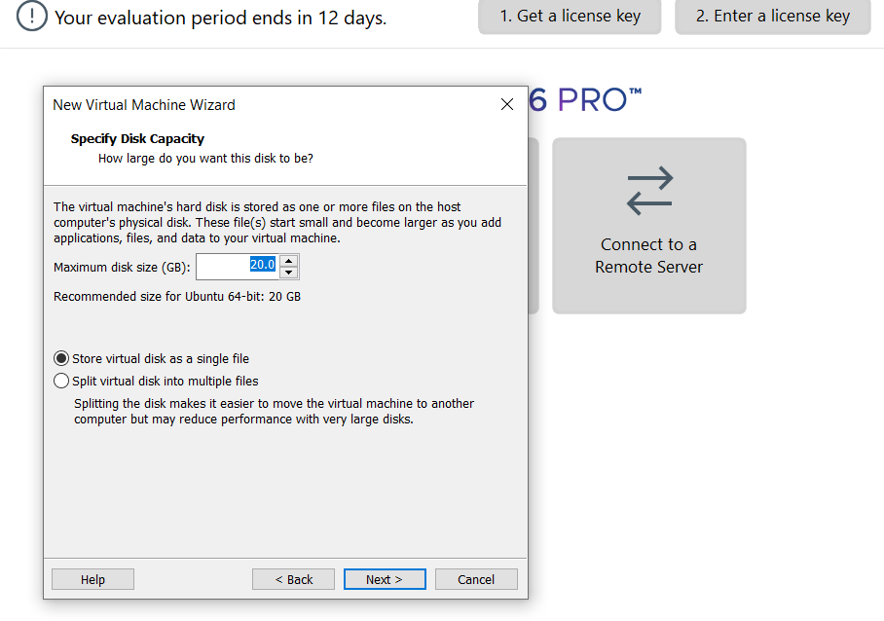

STEP 5: CREATED TINYOS VIRTUAL MACHINE

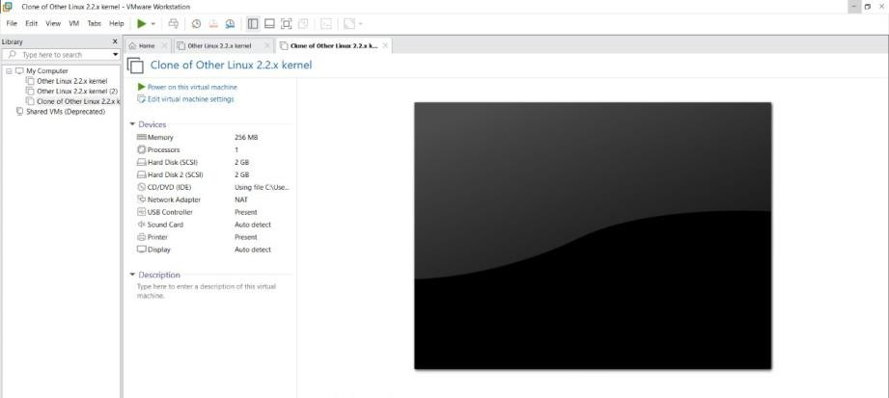

STEP 6: LAUNCH THE VM

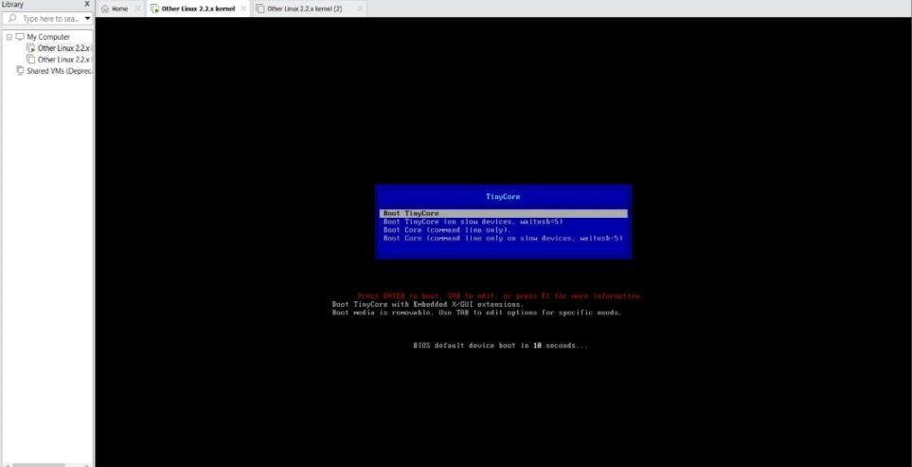

**EXPNO 8: CREATE A VIRTUAL MACHINE WITH 1 CPU, 2GB RAM AND 15GB STORAGE DISK USING A TYPE 2 VIRTUALIZATION SOFTWARE.**

DATE:

AIM:

To create a virtual machine with 1 cpu, 2gb ram and 15gbstorage disk using a type 2 virtualization software**.**

**PROCEDURE:**

**STEP 1:**Dowload VMware workstation and installed as type 2hypervisor.

**STEP2:**Dowload ubuntu or tiny OS as iso image file. **STEP 3:** In VMware workstation->create new VM. **STEP 4:** Do the basic configuration settings.

**STEP 5:** Created tiny OS virtual machine. **STEP 6:** Launch the VM. IMPLEMENTATION:

STEP 1:DOWLOAD VMWARE WORKSTATION AND INSTALLED AS TYPE 2HYPERVISOR



STEP2: DOWLOAD UBUNTU OR TINY OS AS ISO IMAGE FILE



STEP 3: IN VMWARE WORKSTATION->CREATE NEW VM



STEP 4: DO THE BASIC CONFIGURATION SETTINGS.











STEP 5: CREATED TINYOS VIRTUAL MACHINE



EXP 9: CREATE A VIRTUAL HARD DISK AND ALLOCATE THE STORAGEUSING VM WARE WORKSTATION.

DATE:

AIM:

To create a virtual hard disk and allocate the storage using vm ware workstation

PROCEDURE:

**STEP 1:**GOTO VM WARE WORKSTATION.

**STEP2:** RIGHT CLICK THE VM AND GOTO THE SETTINGS.

**STEP 3:** ADD HARDWARE WIZARD AND SELECT SCSI AND CLICK NEXT.

**STEP 4:** CREATE NEW VIRTUAL DISK.

**STEP 5:** SELCT THE DISK SIZE AS 2.0. AND SELCT SPLIT VIRTUAL DISK INTOMULTIFILES.

**STEP 6:** GIVE NAME AND CLICK THE FINISH.

IMPLEMENTATION:

STEP 1:GOTO VM WARE WORKSTATION

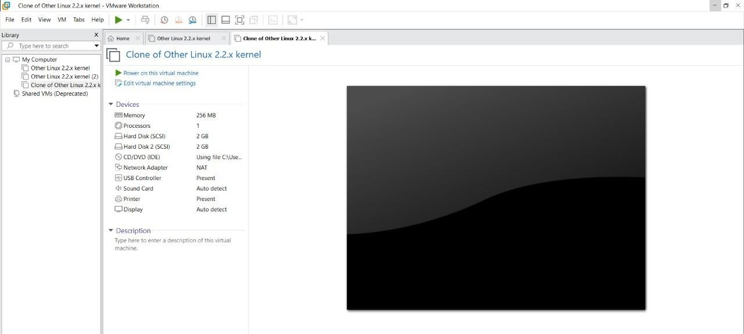

STEP2: RIGHT CLICK THE VM AND GOTO THE SETTINGS

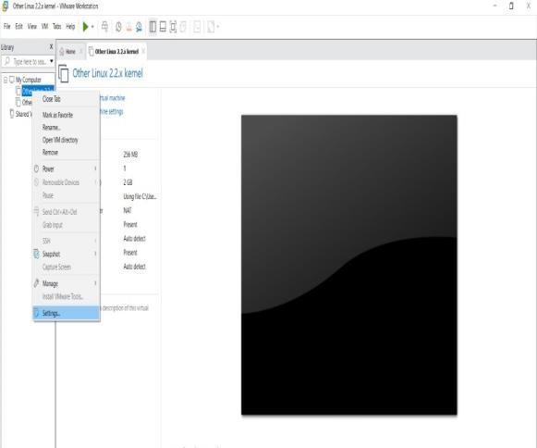

STEP 3: ADD HARDWARE WIZARD AND SELECT SCSI AND CLICK NEXT

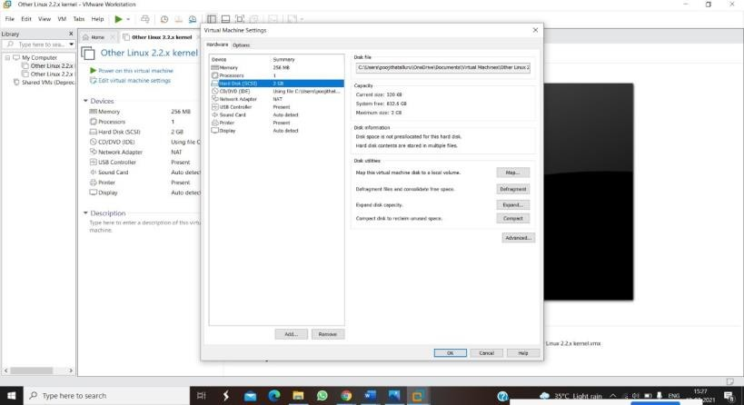

STEP 4: CREATE NEW VIRTUAL DISK

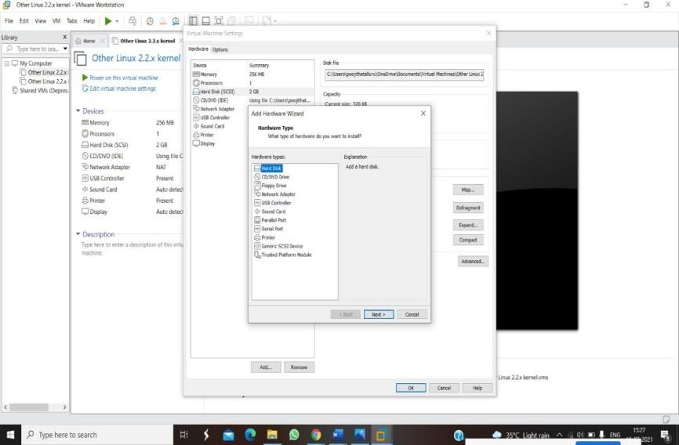

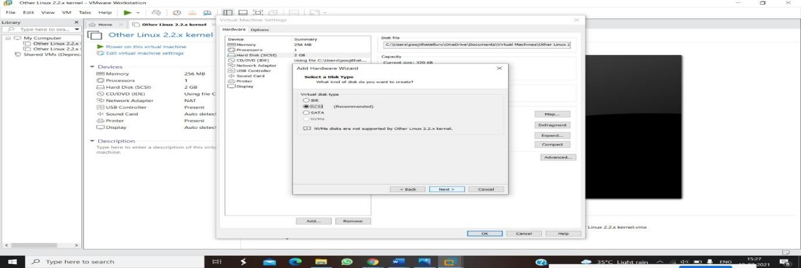

STEP 5: SELCT THE DISK SIZE AS 2.0. AND SELCT SPLIT VIRTUAL DISK INTOMULTIFILES.

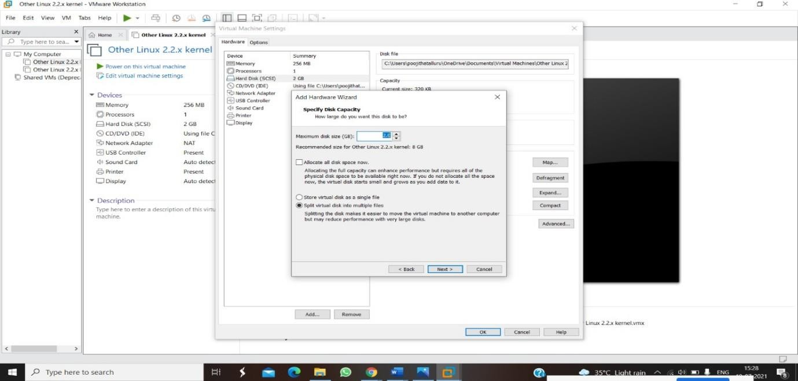

STEP 6: GIVE NAME AND CLICK THE FINISH

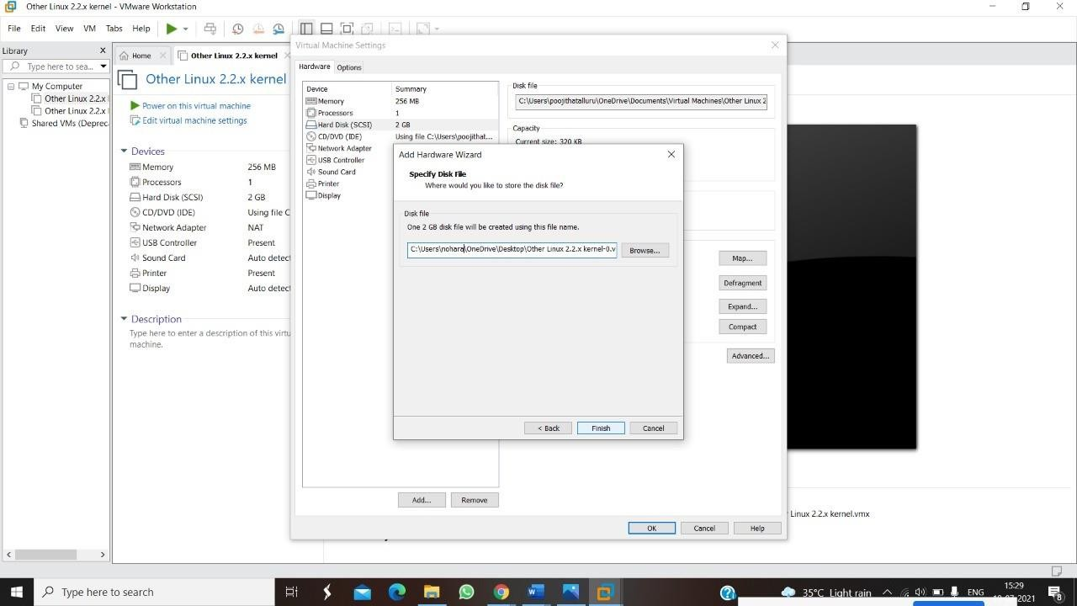

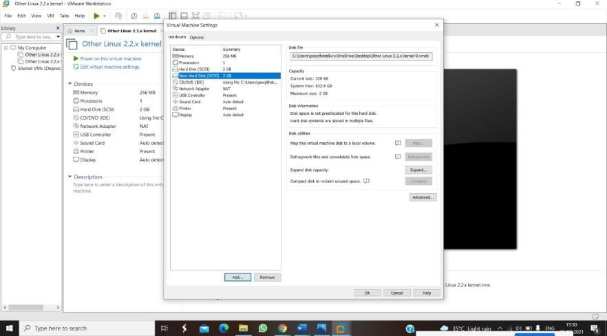

EXPNO 10: CREATE A SNAPSHOT OF A VM AND TEST IT BY LOADING THE PREVIOUS VERSION/CLONED VM

DATE:

AIM:

To create a snapshot of a vm and test it by loading the previous version/cloned vm

PROCEDURE:

**STEP 1:** GOTO VMWARE WORKSTATION**. STEP 2:** CREATE FILES ON DESKTOP.

**STEP 3**: CLICK ON VM AND SELECTS SNAPSHOT-> TAKE SNAPSHOT.

**STEP 4:** SNAPSHOT IS BEING DONE

IMPLEMENTATION:

STEP 1: GOTO VMWARE WORKSTATION

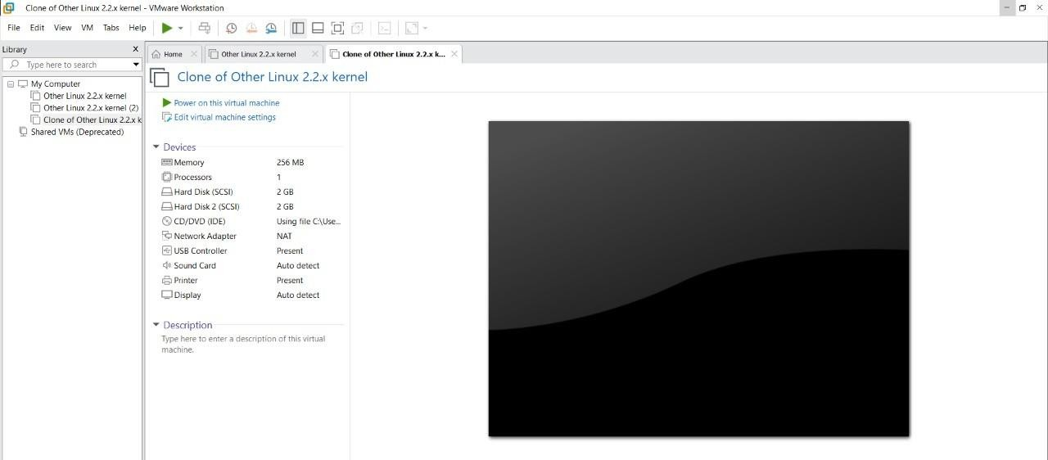

STEP 2: CREATE FILES ON DESKTOP

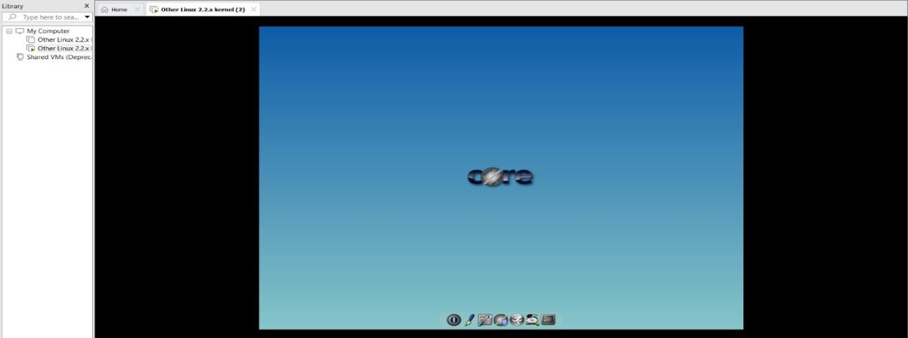

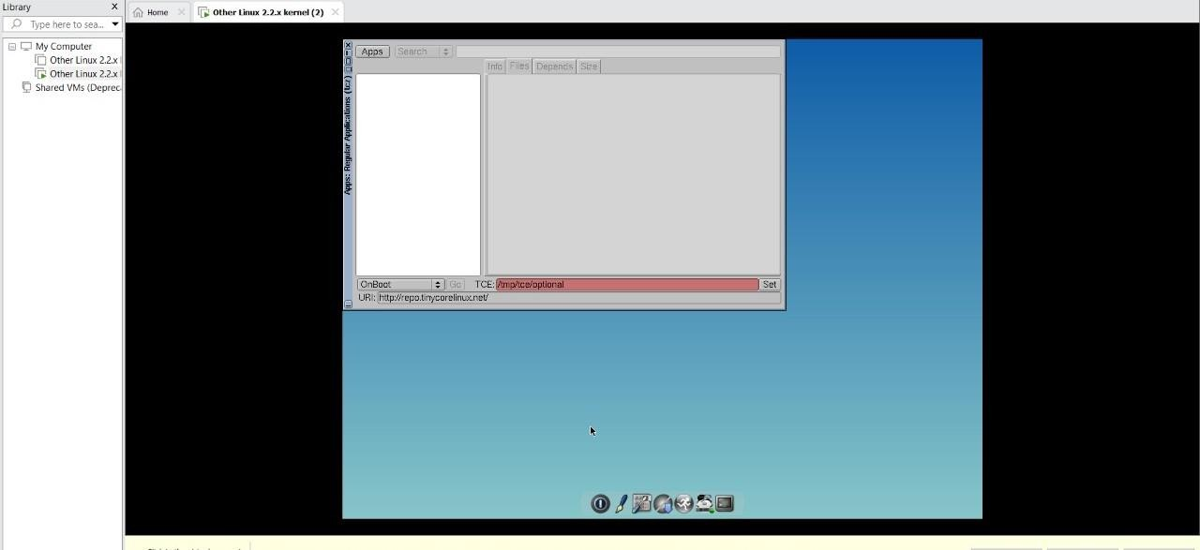

STEP 3: CLICK ON VM AND SELECTS SNAPSHOT-> TAKE SNAPSHOT.

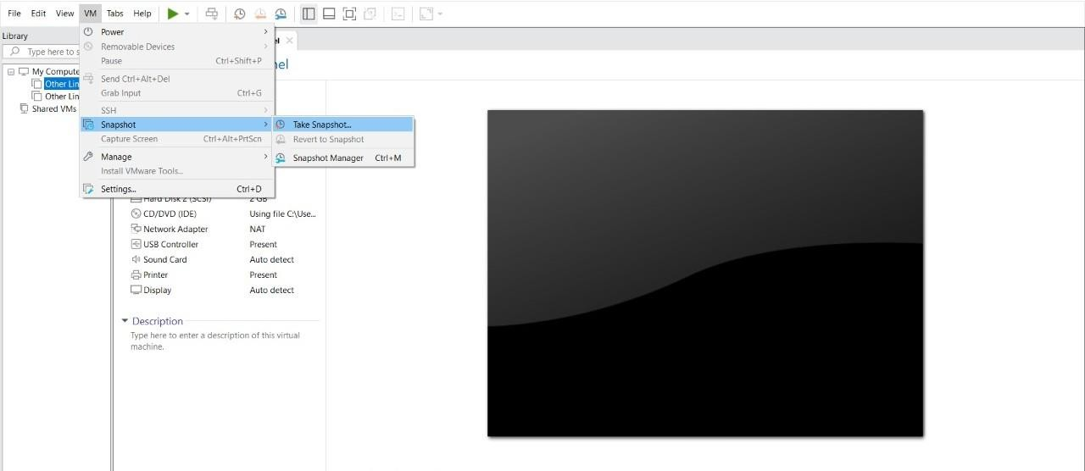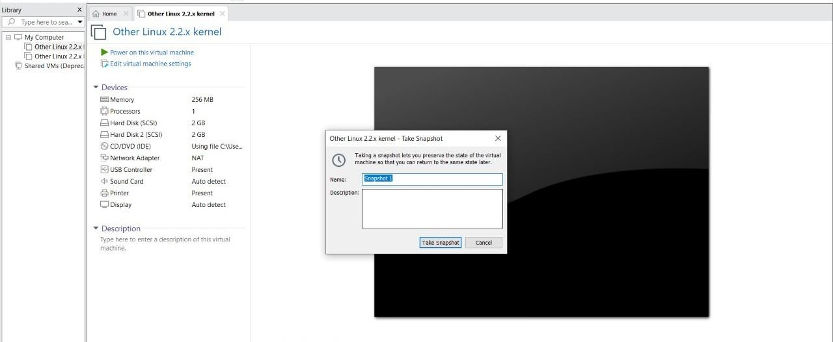

STEP 4: SNAPSHOT IS BEING DONE

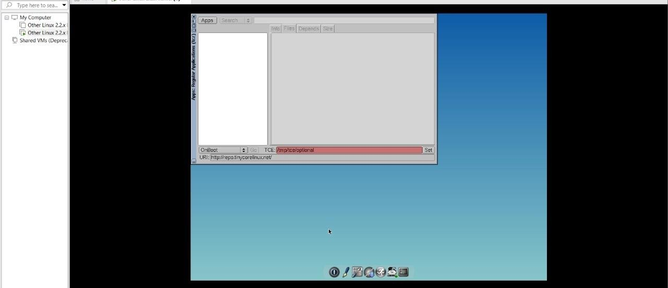

# EXPNO 11: CREATE A CLONING OF A VM AND TEST IT BY LOADING THE PREVIOUS VERSION/CLONED VM.

DATE:

AIM:

To create a cloning of a vm and test it by loading the previous version/cloned vm.

PROCEDURE:

**STEP 1**: GO TO VM AND GOTO MANAGE AND CLICK CLONE

**STEP 2:** CLICK CLONE

**STEP 3:** SELECT THE FULL CLONE

**STEP 4**: AFTER CLONE AGAIN OR VM IS OPENED.

**IMPLEMENTATION:**

CLONING OF A VM

STEP 1: GO TO VM AND GOTO MANAGE AND CLICK CLONE

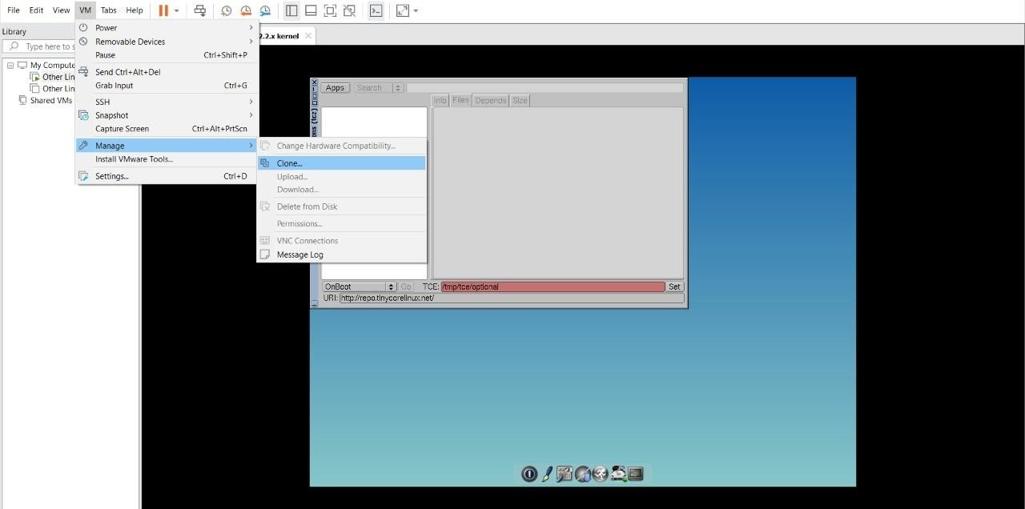

STEP 2: CLICK CLONE

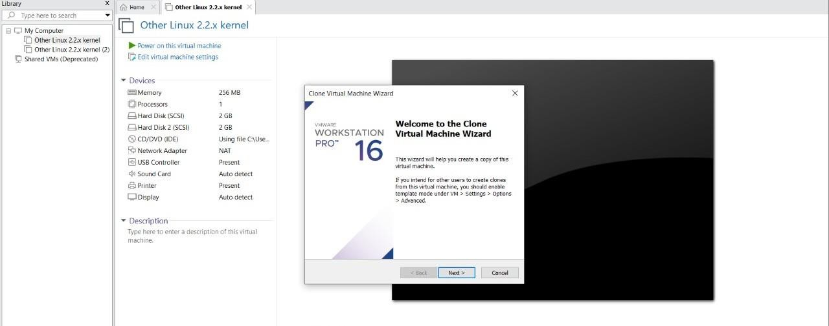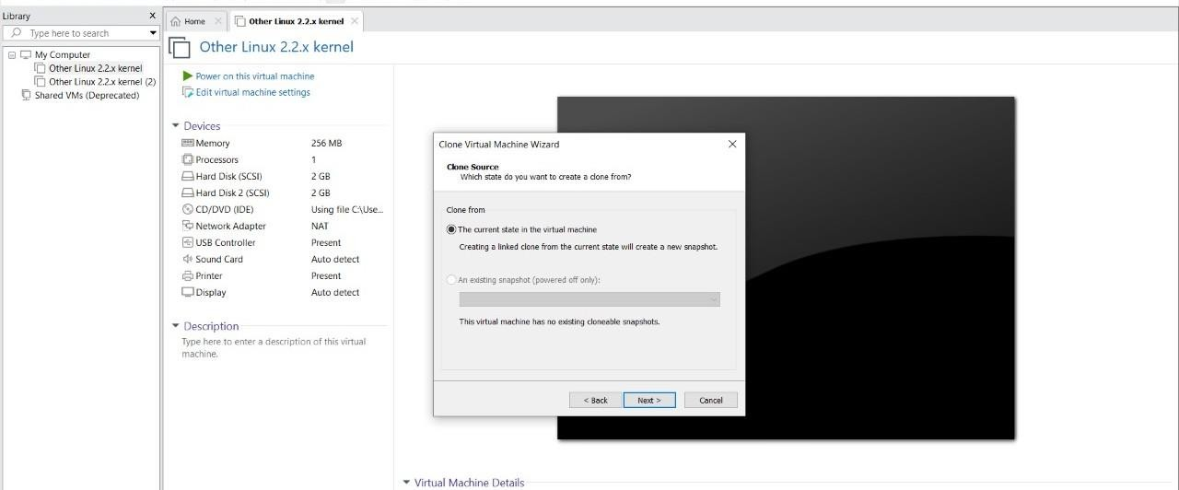

STEP 3: SELECT THE FULL CLONE

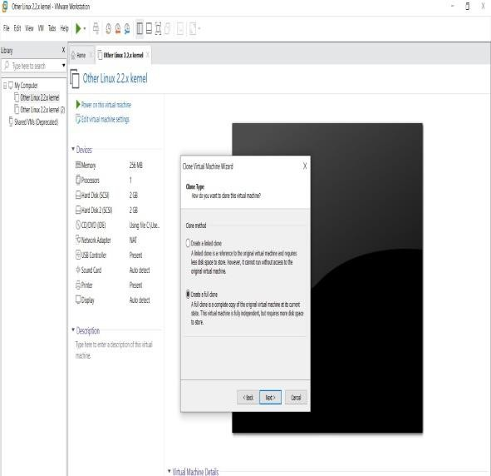

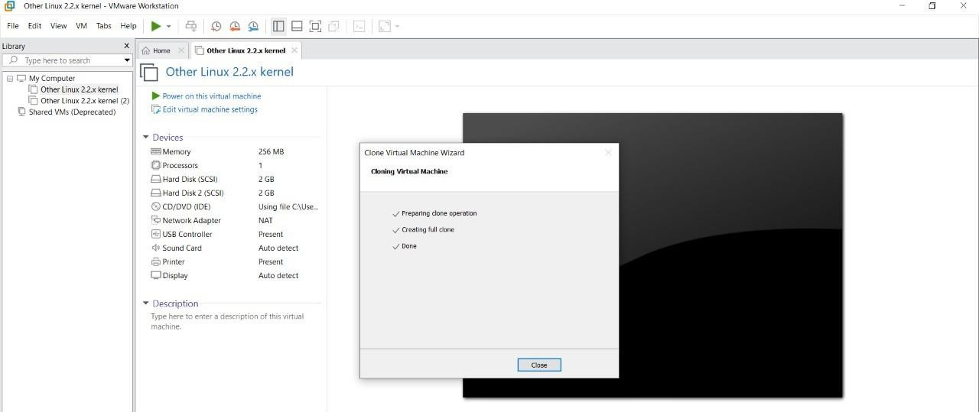

STEP 4: AFTER CLONE AGAIN OR VM IS OPENED.

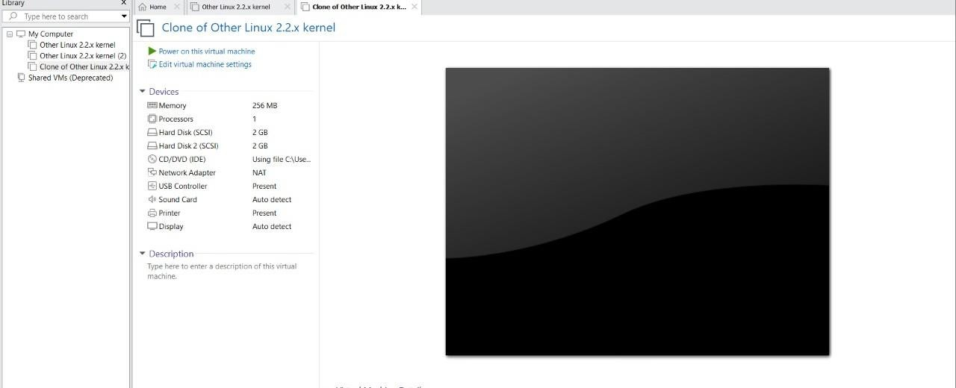

# EXP 12: CHANGE HARDWARE COMPATIBILITY OF A VM (EITHER BY CLONE/CREATE NEW ONE) WHICH IS ALREADY CREATED AND CONFIGURED.

DATE:

AIM:

To Change Hardware compatibility of a VM (Either by clone/create new one) which is already created and configured.

PROCEDURE:

**STEP 1:**GOTO VM WARE WORKSTATION.

**STEP2:** RIGHT CLICK THE VM AND GOTO THE SETTINGS.

**STEP 3:** ADD HARDWARE WIZARD AND SELECT SCSI AND CLICK NEXT.

**STEP 4:** CREATE NEW VIRTUAL DISK.

**STEP 5:** SELCT THE DISK SIZE AS 2.0. AND SELCT SPLIT VIRTUAL DISK INTOMULTIFILES.

**STEP 6:** GIVE NAME AND CLICK THE FINISH.

IMPLEMENTATION:

STEP 1:GOTO VM WARE WORKSTATION



STEP2: RIGHT CLICK THE VM AND GOTO THE SETTINGS



STEP 3: ADD HARDWARE WIZARD AND SELECT SCSI AND CLICK NEXT



STEP 4: CREATE NEW VIRTUAL DISK





STEP 5: SELCT THE DISK SIZE AS 2.0. AND SELCT SPLIT VIRTUAL DISK INTOMULTIFILES.



STEP 6: GIVE NAME AND CLICK THE FINISH





# EXP13. DEMONSTRATE INFRASTRUCTURE AS A SERVICE (IAAS) BY CREATING A VIRTUAL MACHINE USING A PUBLIC CLOUD SERVICE PROVIDER (AZURE), CONFIGURE WITH REQUIRED MEMORY AND CPU.

**AIM:**

To demonstrate infrastructure as a service (iaas) by creating a virtual machine using a public cloud service provider (azure), configure with required memory and cpu.

# PROCEDURE:

**STEP1:** CREATE AN ACCOUNT IN MICROSOFT AZURE.

**STEP2:** GOTO RESOURCE GROUPAND CREATE A RESOURCE GROUP.

**STEP3:** GIVE NECESSARY THINGS FOR RESOURCE GROUP.

**STEP4:** CREATE A VIRTUAL NETWORK FOR TO CREATE A VIRTUALMACHINE .

**STEP5**: NOW CREATE A VIRTUAL MACHINE WITH UR IP ADDRESS ANUSERNAME AND PASSWORD FOR YOUR VIRTUAL MACINE.

**STEP6**: AND YOUR VIRTUAL MACHINE IS DEPLOYED.

**STEP7:** NOW CONNECT THE VIRTUAL MACHINE AND DOWNLOAD THE RDP FILETO OPEN YOUR WINDOWS VIRTUAL MACHINE.

**STEP8:** NOW RESIZE THE VIRTUAL MACHINE SIZE.

**STEP9:** CREATED A NEW WINDOWS VIRTUAL MACHINE

IMPLEMENTATION:

STEP1:CREATE AN ACCOUNT IN MICROSOFT AZURE.

STEP2: GOTO RESOURCE GROUP AND CREATE A RESOURCE GROUP.

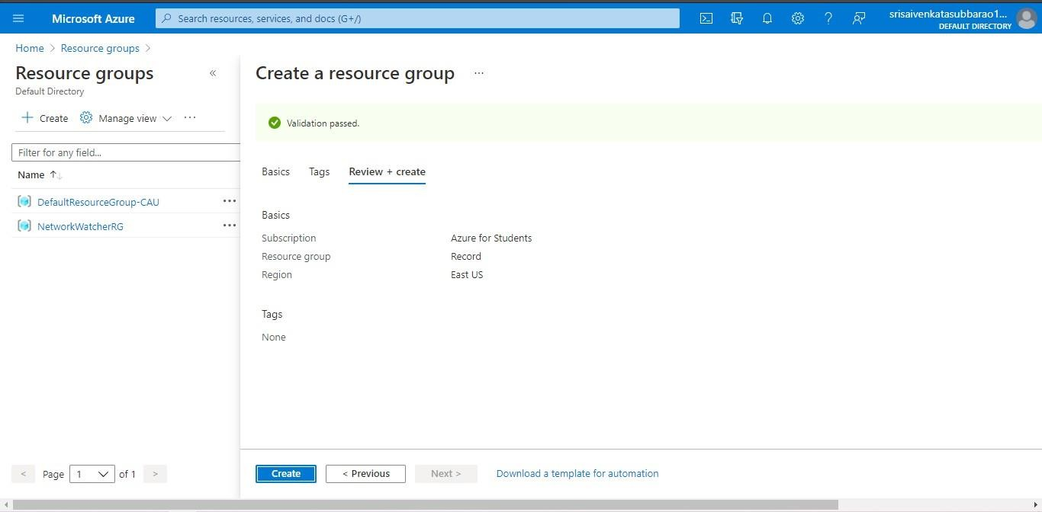

STEP3: GIVE NECESSARY THINGS FOR RESOURCE GROUP.

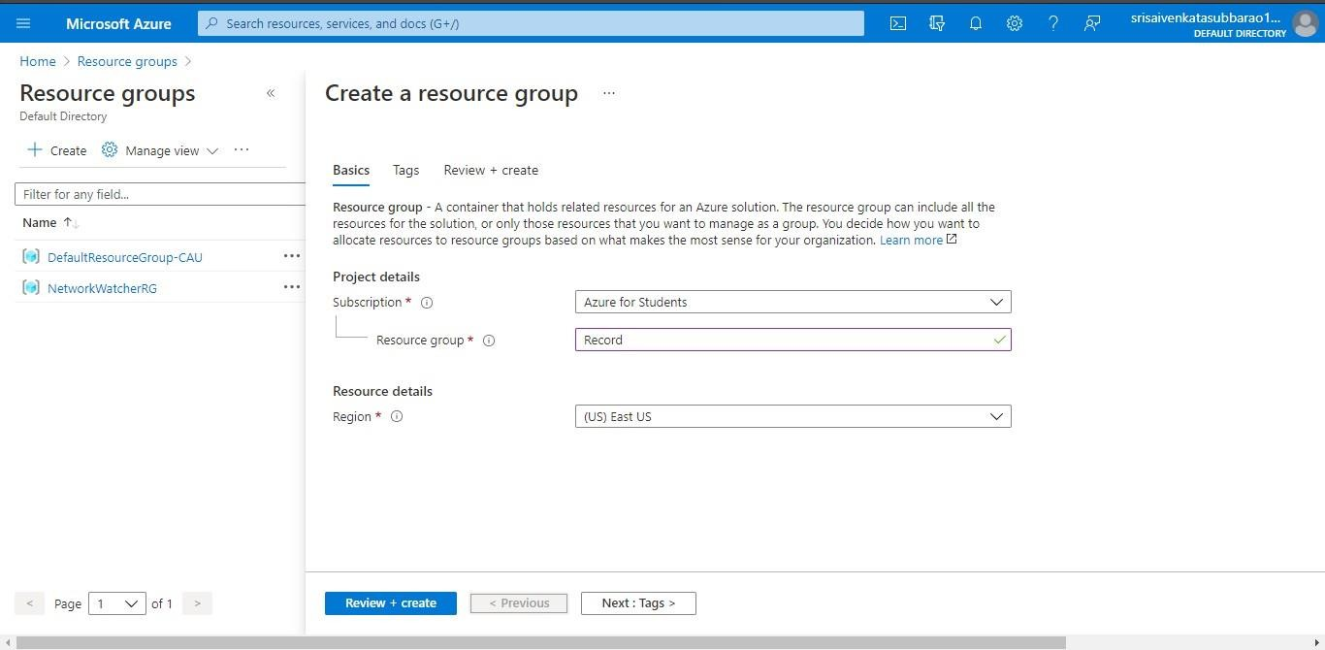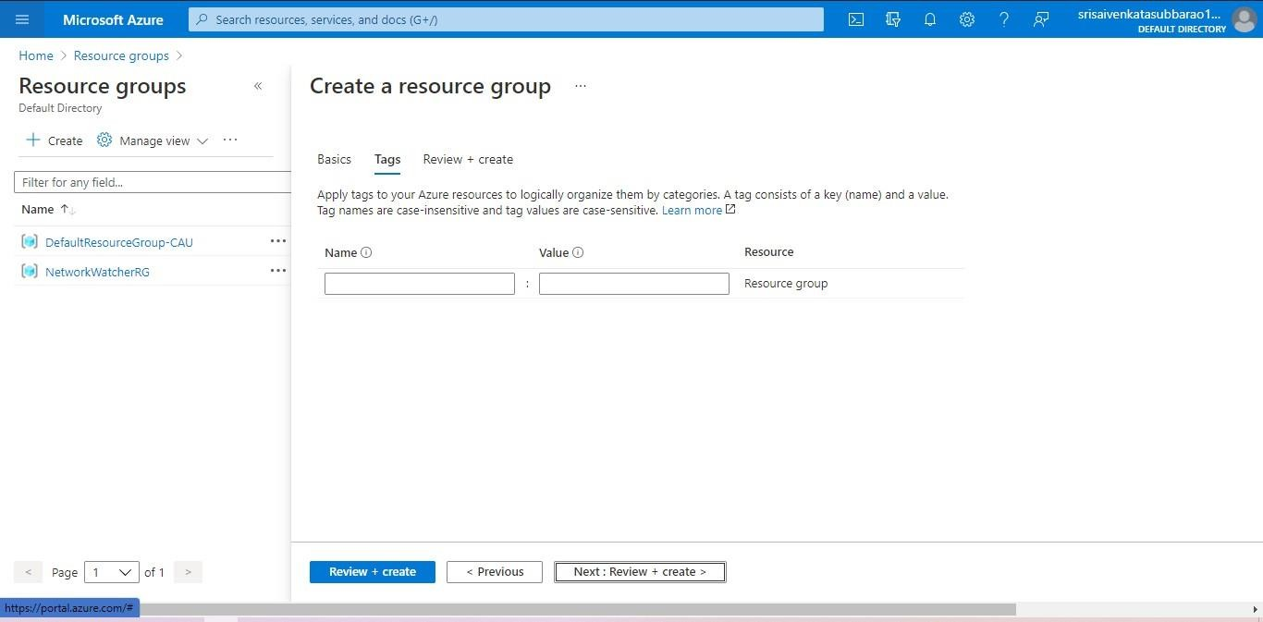

STEP4: CREATE A VIRTUAL NETWORK FOR TO CREATE A VIRTUALMACHINE .

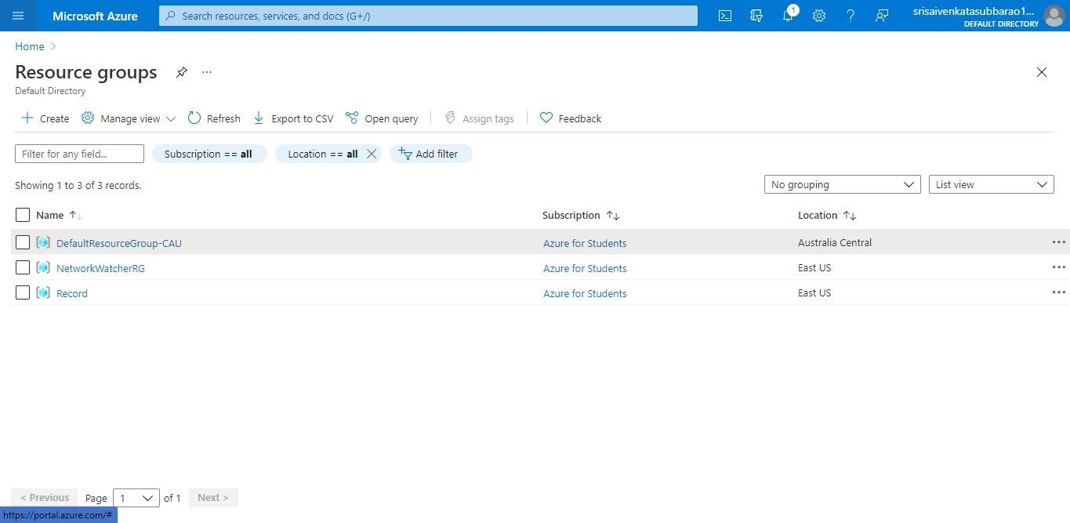

STEP5: NOW CREATE A VIRTUAL MACHINE WITH UR IPADDRESS ANUSERNAME AND PASSWORD FOR YOUR VIRTUAL MACINE.

STEP6: AND YOUR VIRTUAL MACHINE IS DEPLOYED.

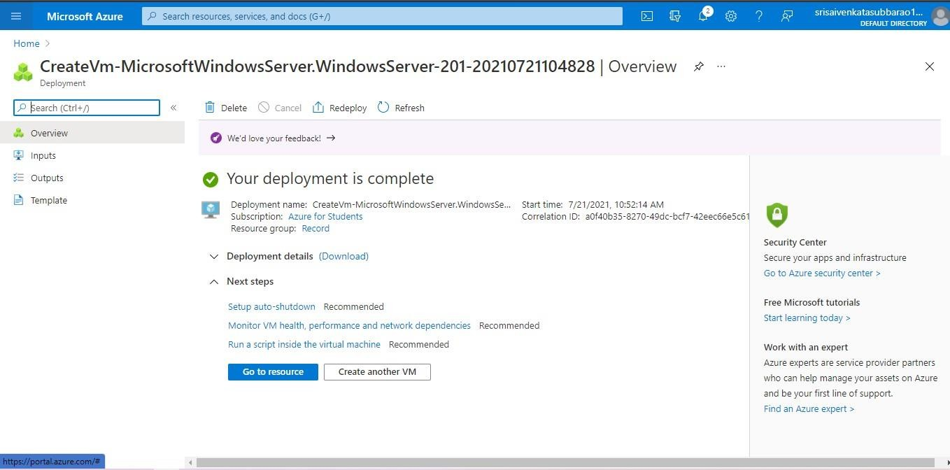

**STEP7: NOW CONNECT THE VIRTUAL MACHINE AND DOWNLOAD THE RDP FILETO OPEN YOUR WINDOWS VIRTUAL MACHINE.**

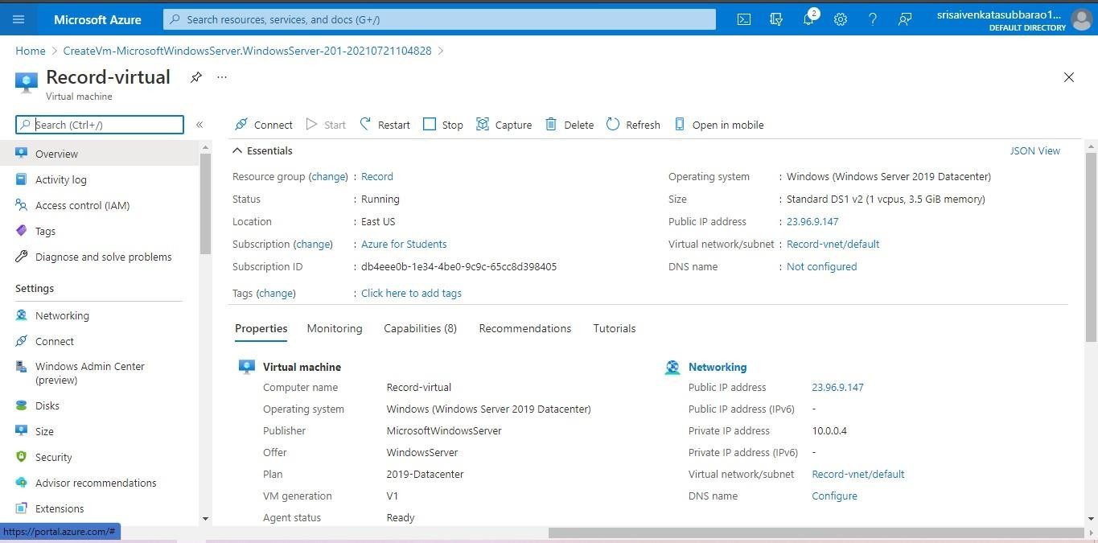

STEP8: CREATED A NEW WINDOWS VIRTUAL MACHINE.



EXP 17 .DEMONSTRATE INFRASTRUCTURE AS A SERVICE(IAAS) BY CREATING AVIRTUAL MACHINE USING A PUBLIC CLOUD SERVICE PROVIDER(AZURE/GCP/AWS) CONFIGURE WITH MINIMUM CPU, RAM ANDSTORAGE AND LAUNCH THE VM IMAGE.

# AIM:

To demonstrate infrastructure as a service(iaas) by creating a virtual machine using a public cloud service provider(azure/gcp/aws) configure with minimum cpu,ram and storage and launch the vm image.

# PROCEDURE:

**STEP1:** CREATE AN ACCOUNT IN MICROSOFT AZURE.

**STEP2:** GOTO RESOURCE GROUPAND CREATE A RESOURCE GROUP.

**STEP3:** GIVE NECESSARY THINGS FOR RESOURCE GROUP.

**STEP4:** CREATE A VIRTUAL NETWORK FOR TO CREATE A VIRTUALMACHINE.

**STEP5**: NOW CREATE A VIRTUAL MACHINE WITH UR IP ADDRESS ANUSERNAME AND PASSWORD FOR YOUR VIRTUAL MACINE.

**STEP6**: AND YOUR VIRTUAL MACHINE IS DEPLOYED.

**STEP7:** NOW CONNECT THE VIRTUAL MACHINE AND DOWNLOAD THE RDP FILETO OPEN YOUR WINDOWS VIRTUAL MACHINE.

**STEP8:** CREATED A NEW WINDOWS VIRTUAL MACHINE

IMPLEMENTATION:

STEP1: CREATE AN ACCOUNT IN MICROSOFT AZURE.

STEP2: GOTO RESOURCE GROUP AND CREATE A RESOURCE GROUP.



STEP3: GIVE NECESSARY THINGS FOR RESOURCE GROUP.



STEP4: CREATE A VIRTUAL NETWORK FOR TO CREATE A VIRTUALMACHINE .



STEP5: NOW CREATE A VIRTUAL MACHINE WITH UR IPADDRESS ANUSERNAME AND PASSWORD FOR YOUR VIRTUAL MACINE.

STEP6: AND YOUR VIRTUAL MACHINE IS DEPLOYED.



**STEP7: NOW CONNECT THE VIRTUAL MACHINE AND DOWNLOAD THE RDP FILETO OPEN YOUR WINDOWS VIRTUAL MACHINE.**



STEP8: CREATED A NEW WINDOWS VIRTUAL MACHINE.



EXP15.CREATE A SIMPLE WEB SITE USING ANY PUBLIC CLOUD SERVICE PROVIDER (AZURE/GCP/AWS) AND CHECK THE PUBLIC ACCESSIBILITY OFTHE STORED FILE TO DEMONSTRATE STORAGE AS A SERVICE

**AIM:** CREATE A SIMPLE WEB SITE USING ANY PUBLIC CLOUD SERVICE PROVIDER (AZURE/GCP/AWS) AND CHECK THE PUBLIC ACCESSIBILITY OFTHE STORED FILE TO DEMONSTRATE STORAGE AS A SERVICE

Procedure:

**STEP1:** FIRSTLY, GO TO APPSERVICE TO CREATE AN WEBAPP.

**STEP2:** ENTER THE RESOURCE GROUP AND WEBAPP NAME AND REGIONAND SELECT THE LINUX OS.

**STEP3:** AFTER ENTER THE ALL THE NECESSARY THINGS CLICK THEREVIEW AND CREATE AND CLICK THE CREATE THE WEB APP.

IMPLEMENTATION:

STEP1: FIRSTLY, GO TO APPSERVICE TO CREATE AN WEBAPP.

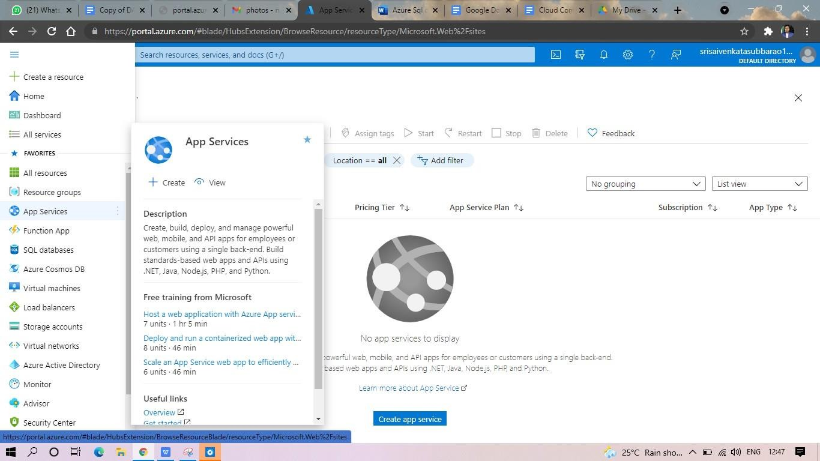

STEP2: ENTER THE RESOURCE GROUP AND WEBAPP NAME AND REGIONAND SELECT THE LINUX OS.

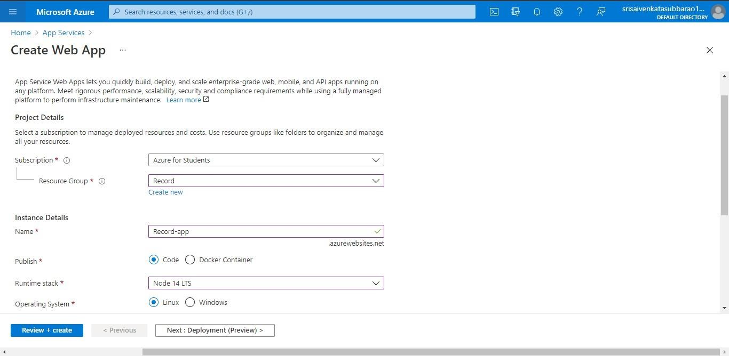

STEP3: AFTER ENTER THE ALL THE NECESSARY THINGS CLICK THEREVIEW AND CREATE AND CLICK THE CREATE THE WEB APP.

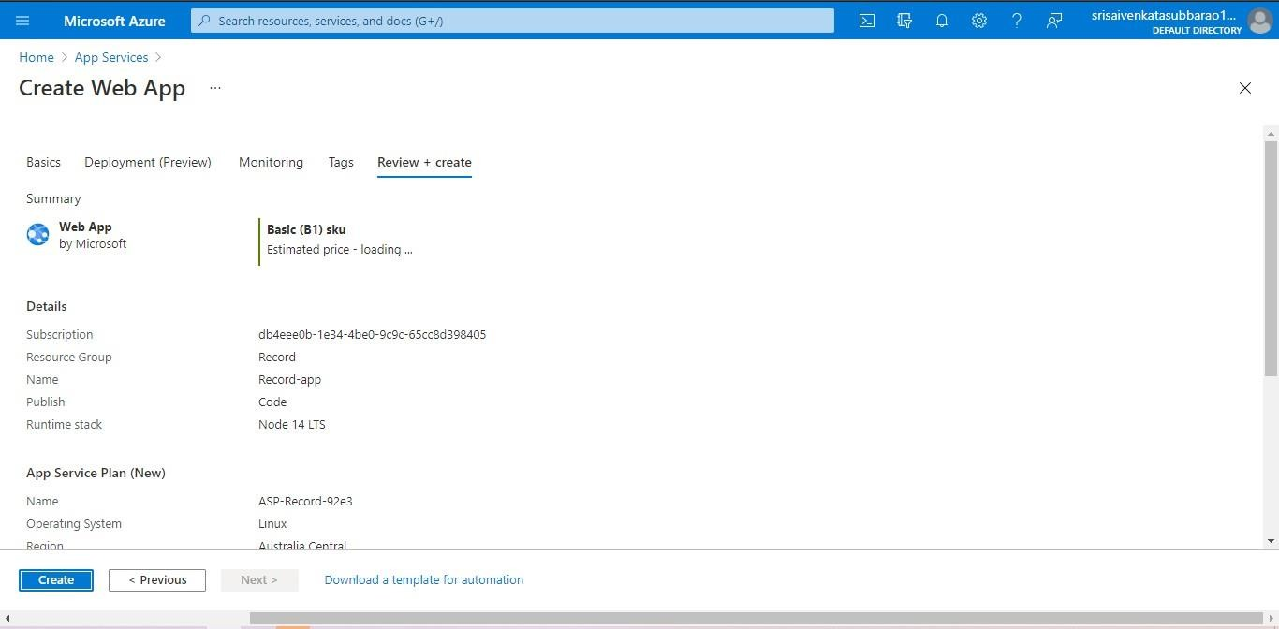

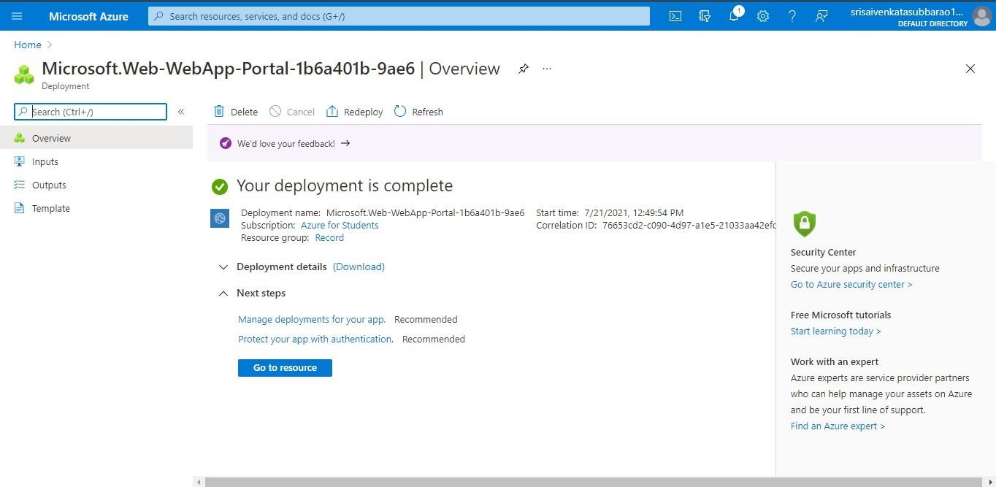

STEP4: AND OUR DEPLOYMENT IS COMPLETED. STEP5: GOTO WEBSITE URL LINK.

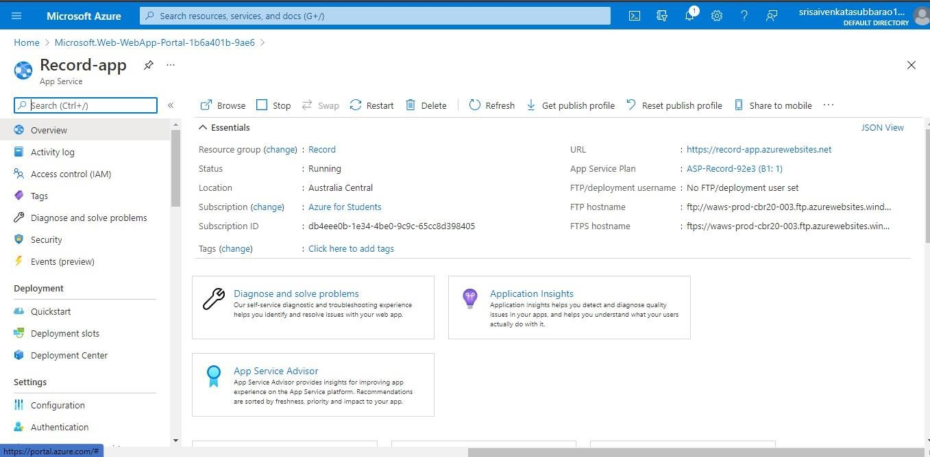

STEP6: THIS IS OUR WEBAPP SERVICE.

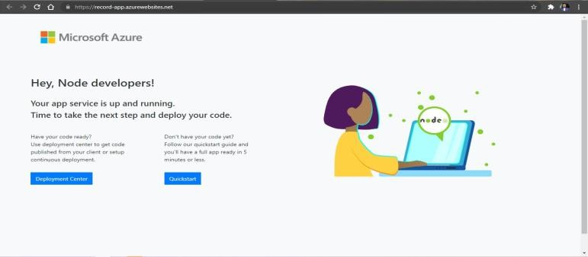

EXP 17 .DEMONSTRATE INFRASTRUCTURE AS A SERVICE(IAAS) BY CREATING AVIRTUAL MACHINE USING A PUBLIC CLOUD SERVICE PROVIDER(AZURE/GCP/AWS) CONFIGURE WITH MINIMUM CPU, RAM ANDSTORAGE AND LAUNCH THE VM IMAGE.

# AIM:

To demonstrate infrastructure as a service(iaas) by creating a virtual machine using a public cloud service provider(azure/gcp/aws) configure with minimum cpu,ram and storage and launch the vm image.

# PROCEDURE:

**STEP1:** CREATE AN ACCOUNT IN MICROSOFT AZURE.

**STEP2:** GOTO RESOURCE GROUPAND CREATE A RESOURCE GROUP.

**STEP3:** GIVE NECESSARY THINGS FOR RESOURCE GROUP.

**STEP4:** CREATE A VIRTUAL NETWORK FOR TO CREATE A VIRTUALMACHINE.

**STEP5**: NOW CREATE A VIRTUAL MACHINE WITH UR IP ADDRESS ANUSERNAME AND PASSWORD FOR YOUR VIRTUAL MACINE.

**STEP6**: AND YOUR VIRTUAL MACHINE IS DEPLOYED.

**STEP7:** NOW CONNECT THE VIRTUAL MACHINE AND DOWNLOAD THE RDP FILETO OPEN YOUR WINDOWS VIRTUAL MACHINE.

**STEP8:** CREATED A NEW WINDOWS VIRTUAL MACHINE

IMPLEMENTATION:

STEP1: CREATE AN ACCOUNT IN MICROSOFT AZURE.

STEP2: GOTO RESOURCE GROUP AND CREATE A RESOURCE GROUP.



STEP3: GIVE NECESSARY THINGS FOR RESOURCE GROUP.



STEP4: CREATE A VIRTUAL NETWORK FOR TO CREATE A VIRTUALMACHINE .



STEP5: NOW CREATE A VIRTUAL MACHINE WITH UR IPADDRESS ANUSERNAME AND PASSWORD FOR YOUR VIRTUAL MACINE.

STEP6: AND YOUR VIRTUAL MACHINE IS DEPLOYED.



**STEP7: NOW CONNECT THE VIRTUAL MACHINE AND DOWNLOAD THE RDP FILETO OPEN YOUR WINDOWS VIRTUAL MACHINE.**



STEP8: CREATED A NEW WINDOWS VIRTUAL MACHINE.



EXP19.CREATE A STORAGE SERVICE USING ANY PUBLIC CLOUD SERVICE PROVIDER (AZURE/GCP/AWS) AND CHECK THE PUBLIC ACCESSIBILITY OFTHE STORED FILE TO DEMONSTRATE STORAGE AS A SERVICE.

AIM:

PROCEDURE:

**STEP1:** OPEN AZURE AND GOTO STORAGE ACCOUNTS AND CREATESTOROAGE ACCOUNT

**STEP2:** ENTER THE RESOURC GROUPAND AND STORAGE ACCOUNT NAMEAND REVIEW AND CREATE AND CLICK TH CREATE AND YOUR STORAGE ACCOUNT WILL BE DEPLOYED SUCESSFULLY.

**STEP3:** OUR STORAGE ACCOUNT IS CREATED.

**STEP4:** GOTO STATIC WEBSITE

**STEP5**: AND ENABLE AND ENTER YOUR INDEX AND ERROR HTML FILES NAMES.

**STEP6:** AND GOTO STORAGE EXPLORR(REVIEW) AND AND GOTO BLOBCONTAINERS AND WEB AND UPLOAD THE TWO HTML FILES INIT

**STEP7: A**ND AGAIN RETURN TO STATIC WEBSITE AND OPEN THE PRIMARYLINK AND YOUR WEB PAGE IS CREATED

IMPLEMENTATION:

STEP1: OPEN AZURE AND GOTO STORAGE ACCOUNTS AND CREATESTOROAGE ACCOUNT

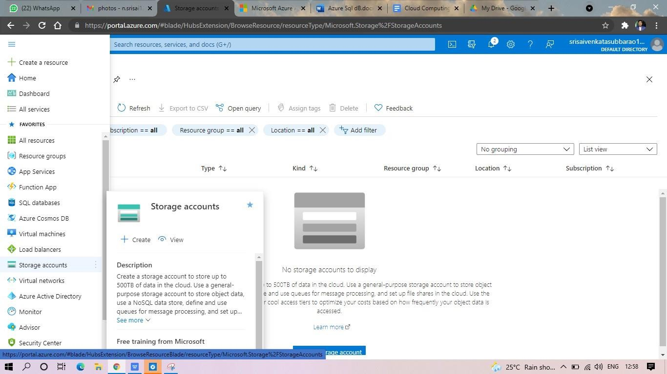

STEP2: ENTER THE RESOURC GROUP AND AND STORAGE ACCOUNT NAMEAND REVIEW AND CREATE AND CLICK TH CREATE AND YOUR STORAGE ACCOUNT WILL BE DEPLOYED SUCESSFULLY.

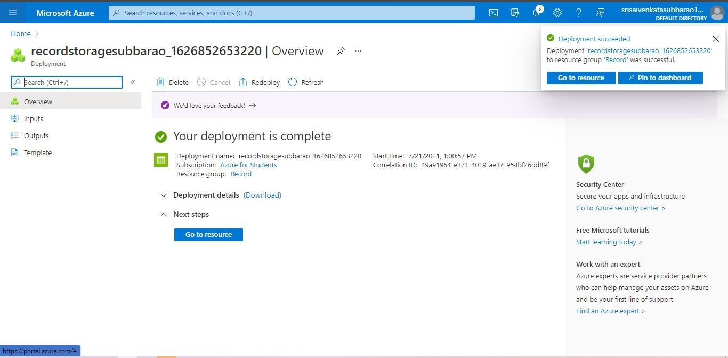

STP3: AND OUR STORAGE ACCOUNT IS CREATED.

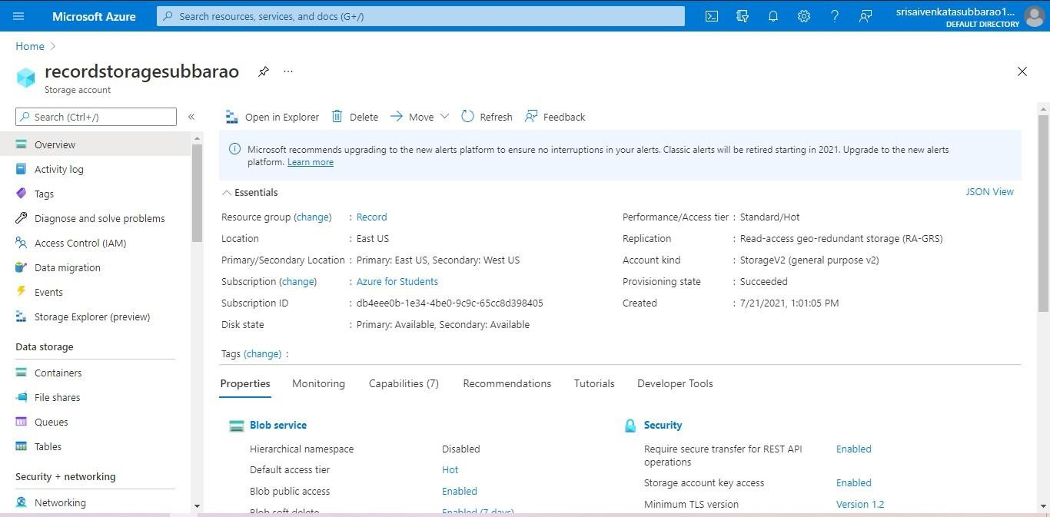

STEP4: GOTO STATIC WEBSITE

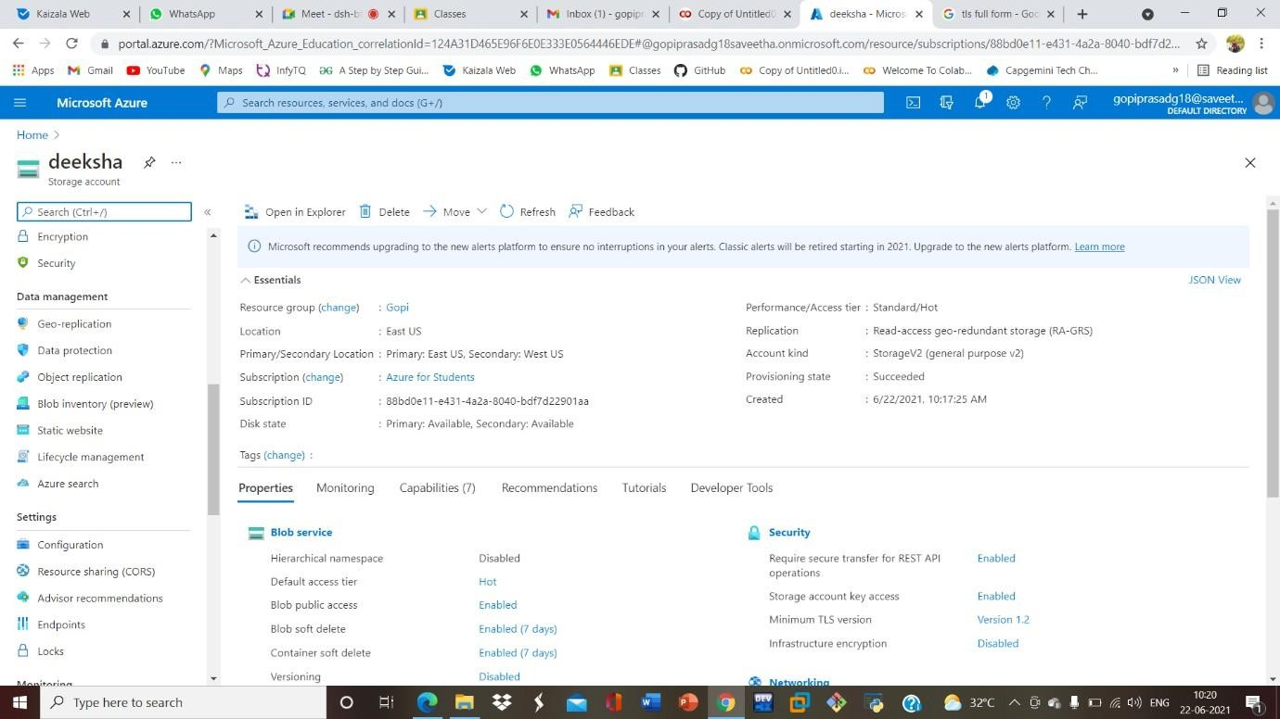

STEP5: AND ENABLE AND ENTER YOUR INDEX AND ERROR HTMLFILESNAMES.

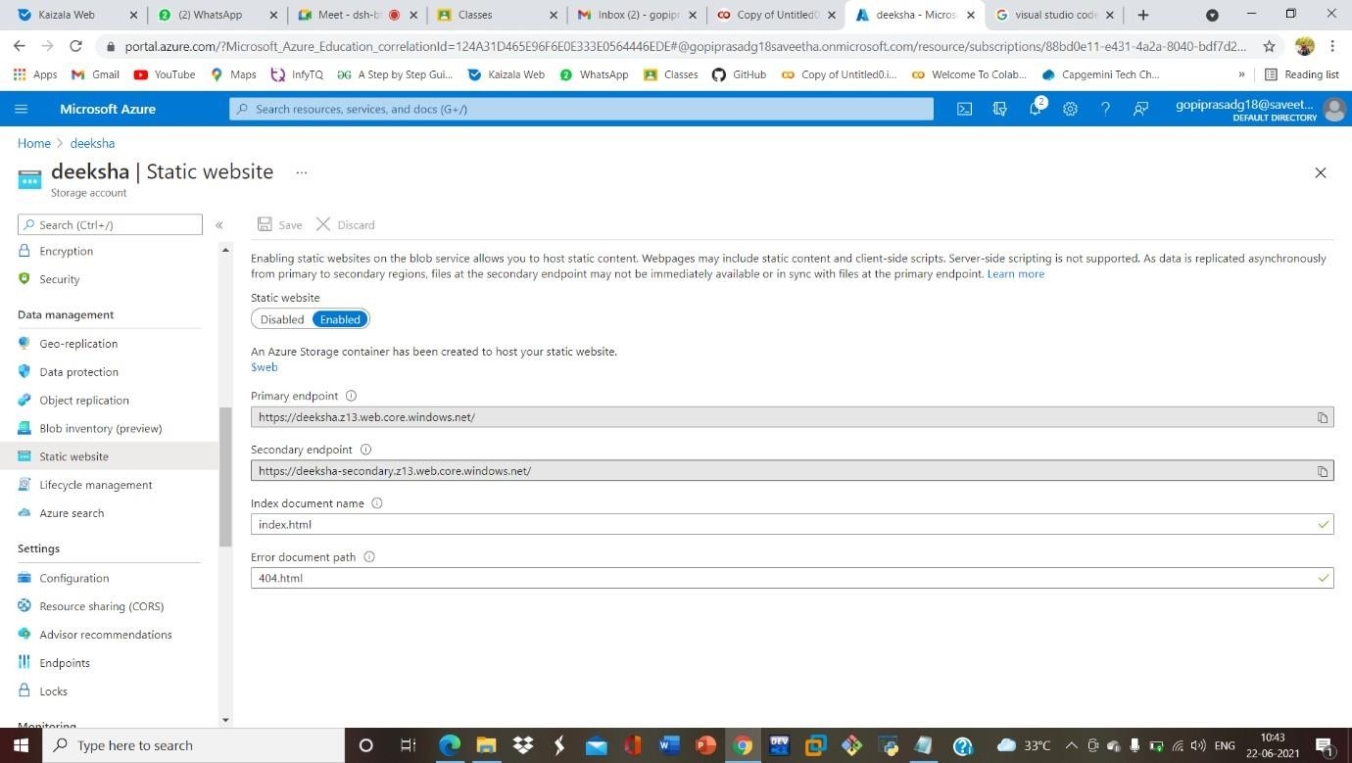

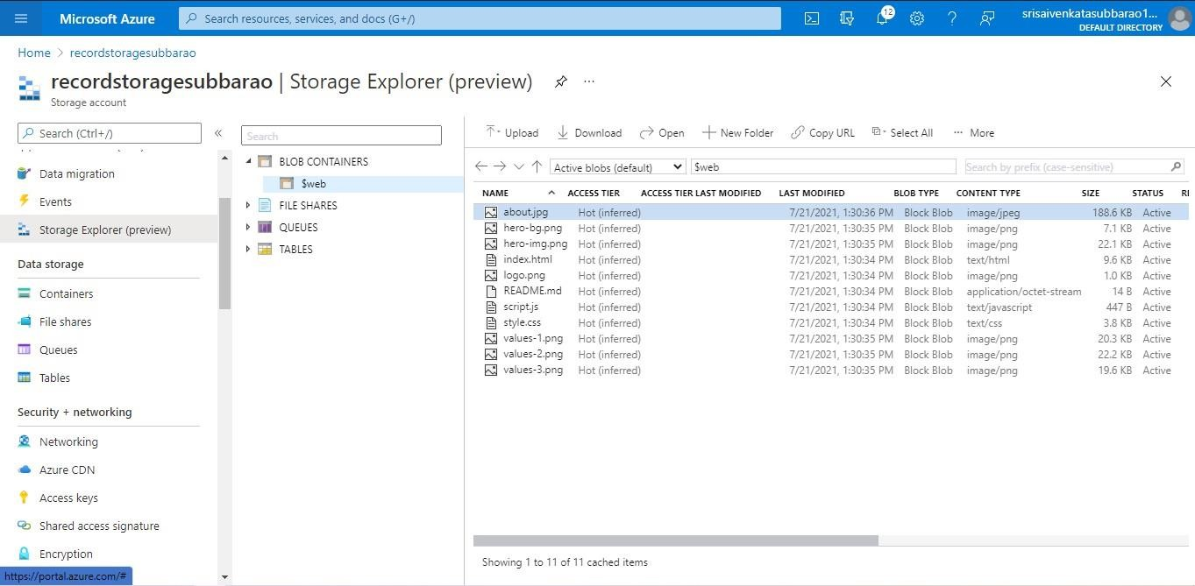STEP6: AND GOTO STORAGE EXPLORR(REVIEW) AND AND GOTO BLOBCONTAINERS AND WEB AND UPLOAD THE TWO HTML FILES INIT

STEP7: AND AGAIN RETURN TO STATIC WEBSITE AND OPEN THE PRIMARYLINK AND YOUR WEB PAGE IS CREATED

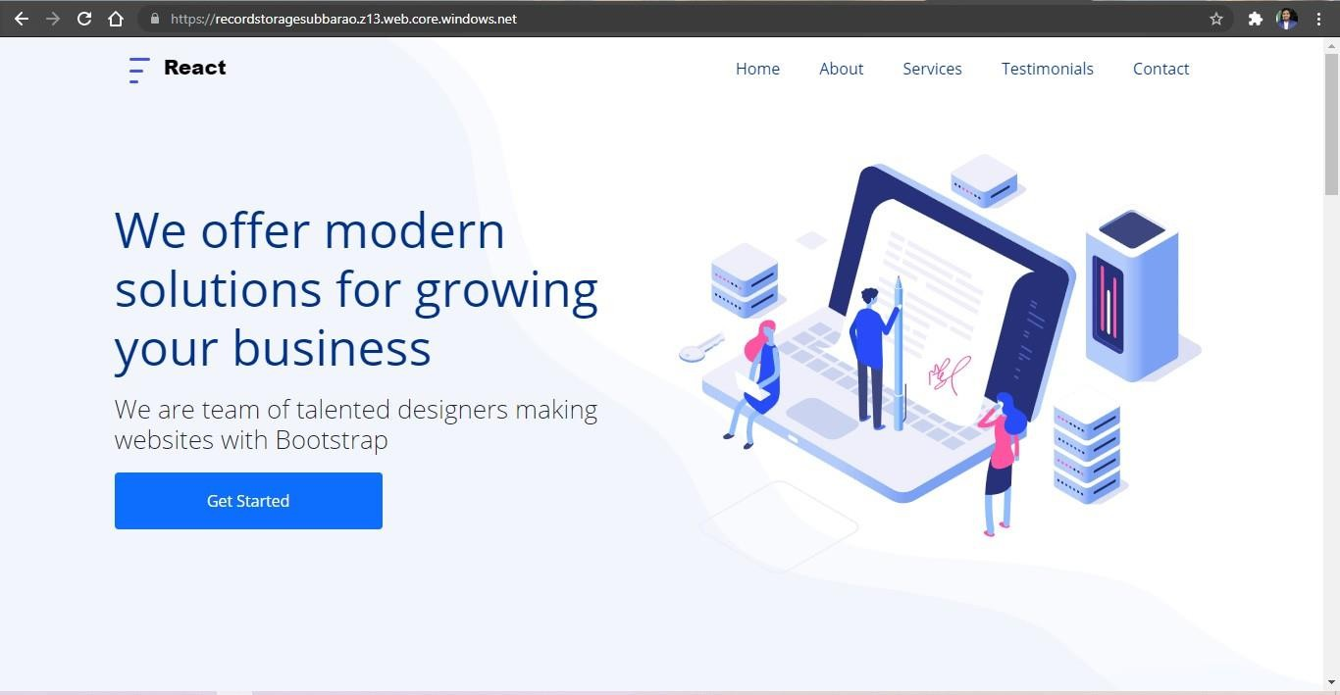

EXP20.CREATE A SQL STORAGE SERVICE AND PERFORM A BASIC QUERY USINGANY PUBLIC CLOUD SERVICE PROVIDER (AZURE/GCP/AWS) TO DEMONSTRATE DATABASE AS A SERVICE (DAAS)

**AIM:** CREATE A SQL STORAGE SERVICE AND PERFORM A BASIC QUERY USINGANY PUBLIC CLOUD SERVICE PROVIDER (AZURE/GCP/AWS) TO DEMONSTRATE DATABASE AS A SERVICE (DAAS)

PROCEDURE:

**STEP1:** GOTO AZURE AND GOTO SQLDATABASE.

**STEP 02:** Now Create a Sql Databse

**STEP3:** SELECT THE RESOURCE GROUPAND ENTER THE SERVERNAMETHAT APPLICABLE.

**STEP4:** IN NETWORKING SELECT ALLOW AZURE SERVICES AND RESOURCES TO ACCESS THIS SERVER.

**STEP5:** IN ADDITIONAL SETTINGS SELECT SAMPLE.

**STEP6:**AND THE SQL DATABASE IS DEPLOYED

**TEP7:** NOW GOTO QUERY EDITOR.

**STEP8:**NOW AGAIN LOGIN TO THE SQLDATADATABASE

**STEP9:** OUR TABLES WILL SHOWN AND TYPE THE QUERY TO EXCUTED.

IMPLEMENTATION:

STEP1: GOTO AZURE AND GOTO SQLDATABASE.

# STEP 02:- Now Create a Sql Databse

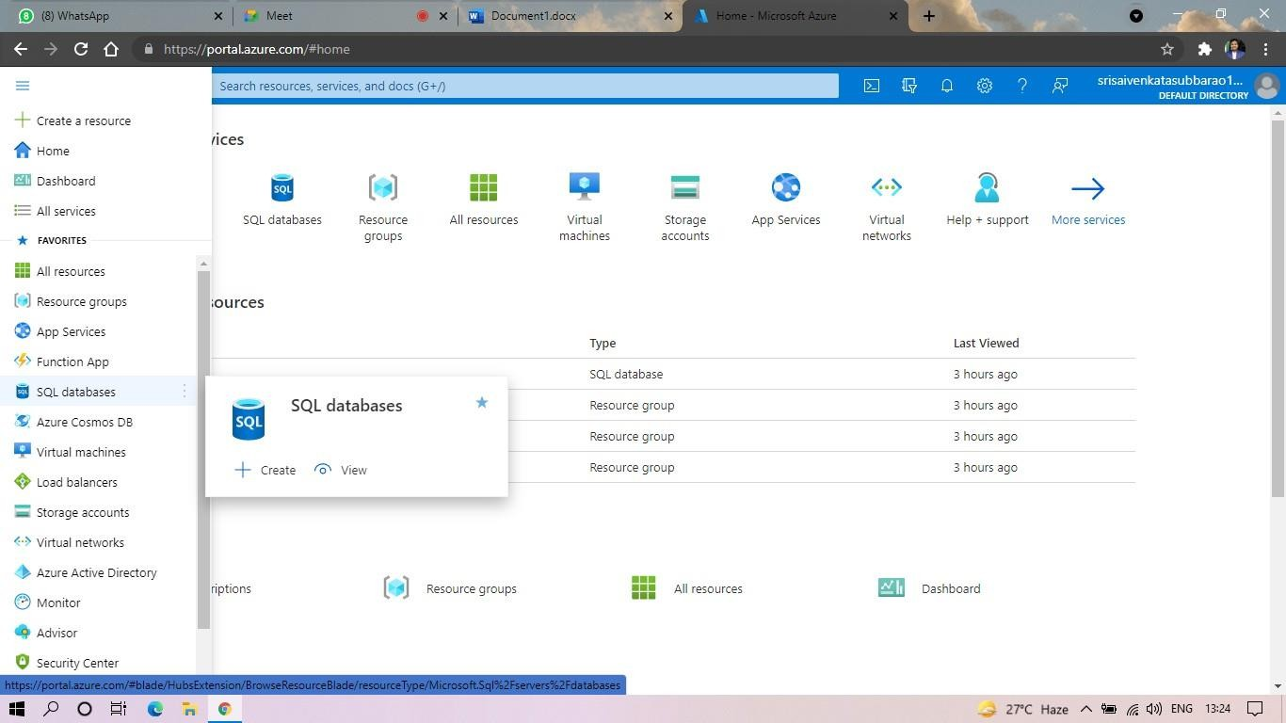

STEP3: SELECT THE RESOURCE GROUP AND ENTER THE SERVERNAMETHAT APPLICABLE.

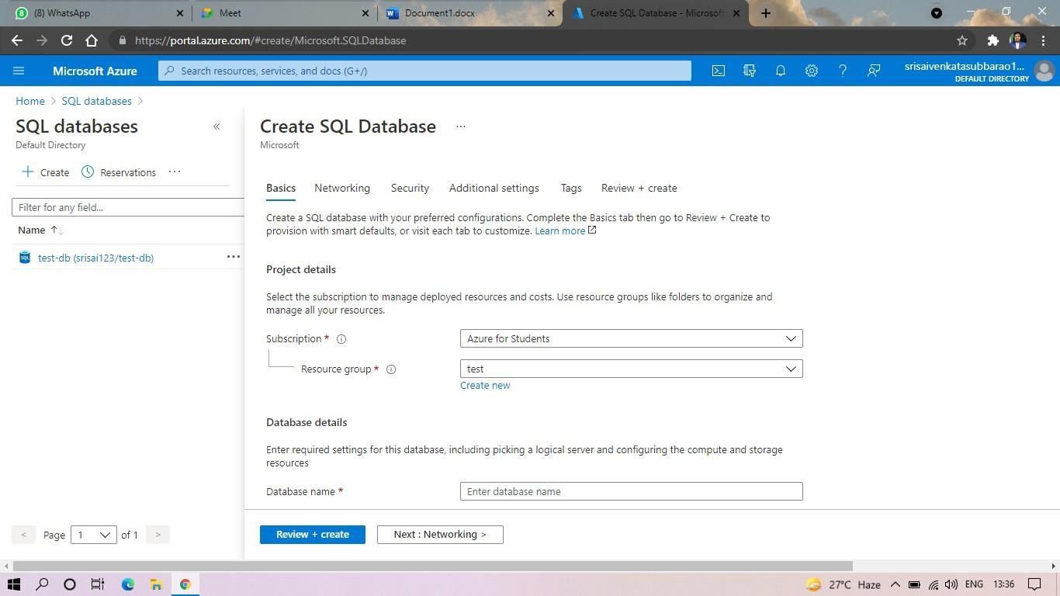

STEP4: IN NETWORKING SELECT ALLOW AZURE SERVICES AND RESOURCES TO ACCESS THIS SERVER.

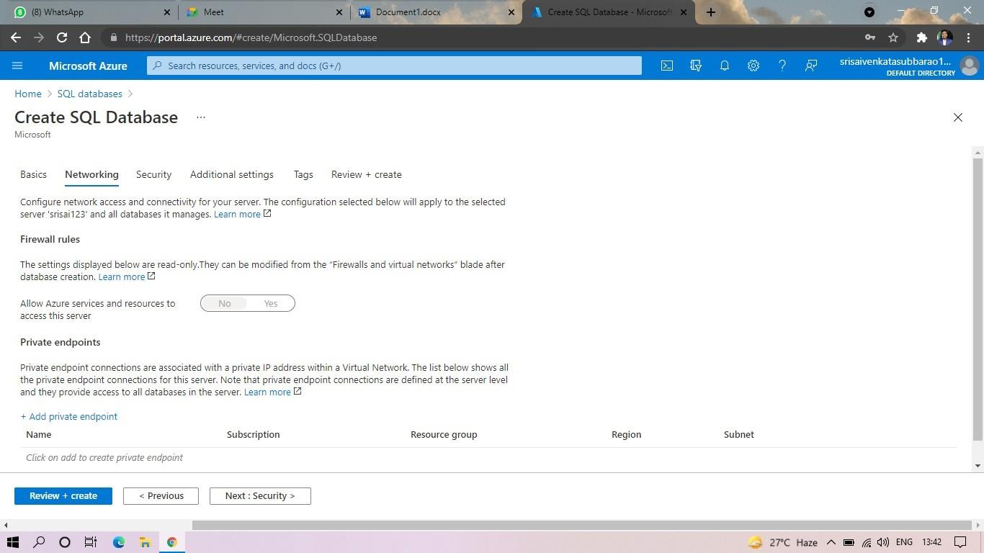

**STEP5: IN ADDITIONAL SETTINGS SELECT SAMPLE.**

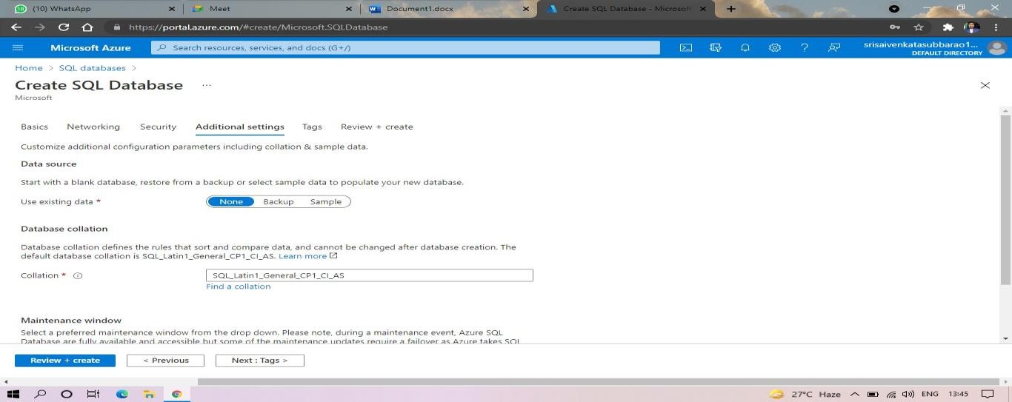

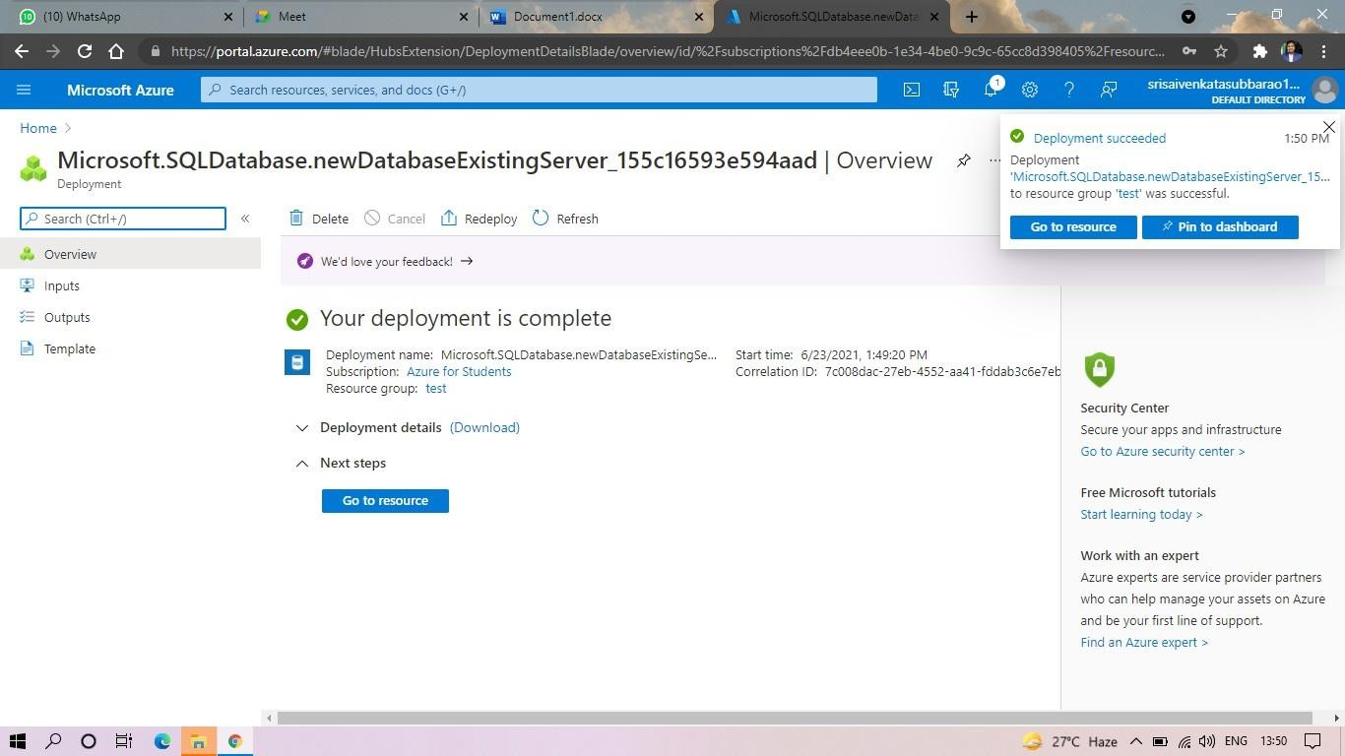**STEP6:AND THE SQL DATABASE IS DEPLOYED.**

**STEP7:AND NOW GOTO QUERY EDITOR.**

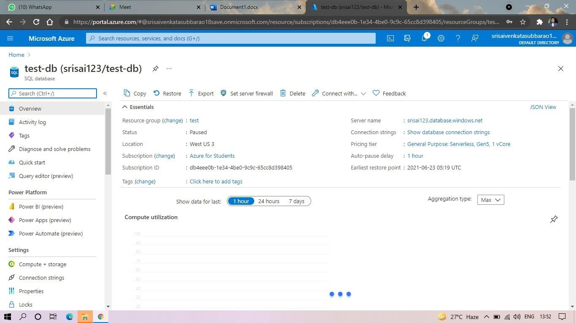

**STEP8:AND NOW AGAIN LOGIN TO THE SQLDATADATABASE**

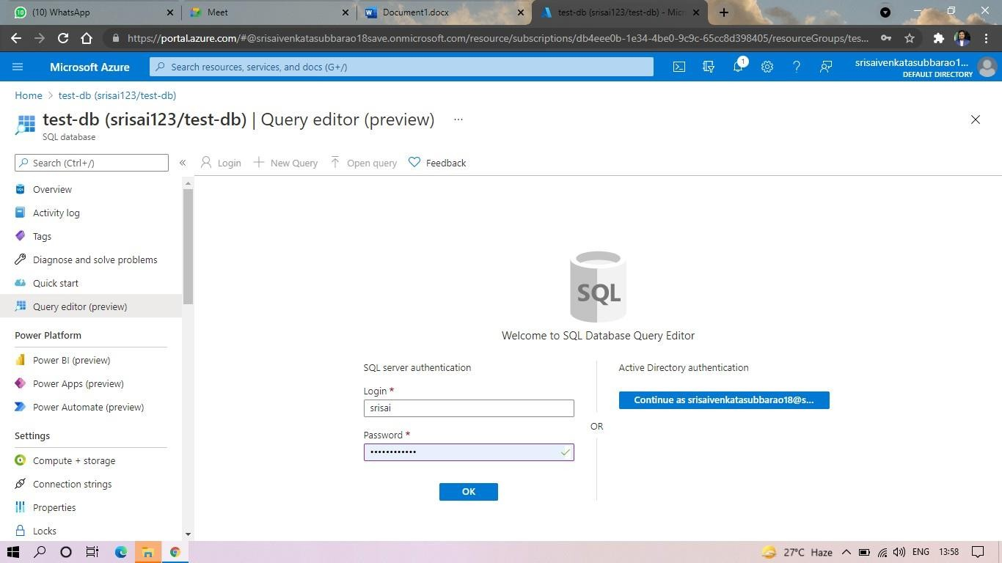

**STEP9: AND OUR TABLES WILL SHOWN AND TYPE THE QUERY TOEXCUTED.**

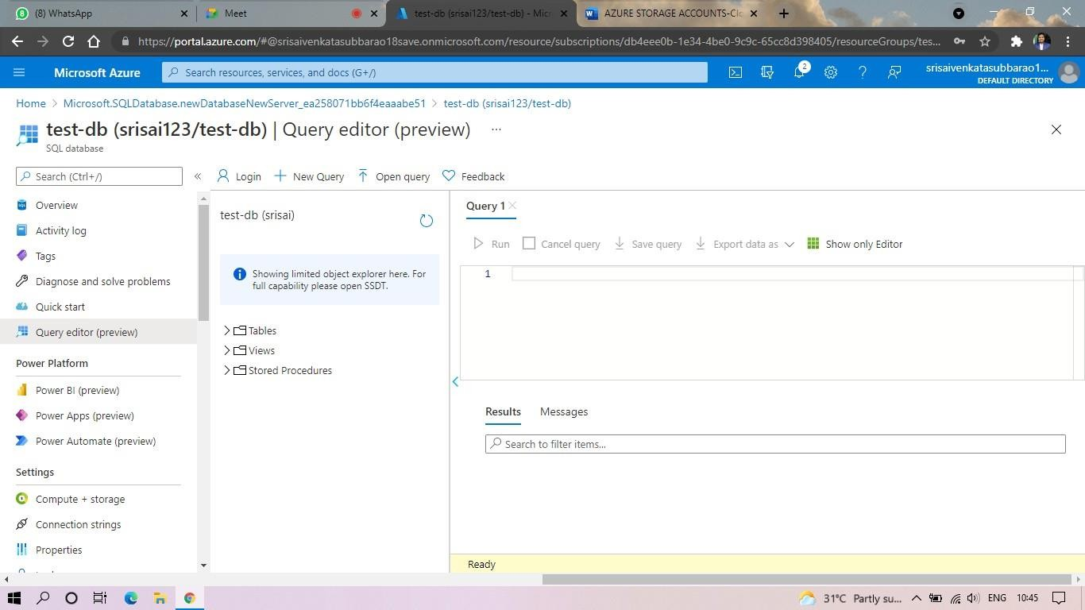

**STEP10: AND OUR OUTPUT IS READY.**

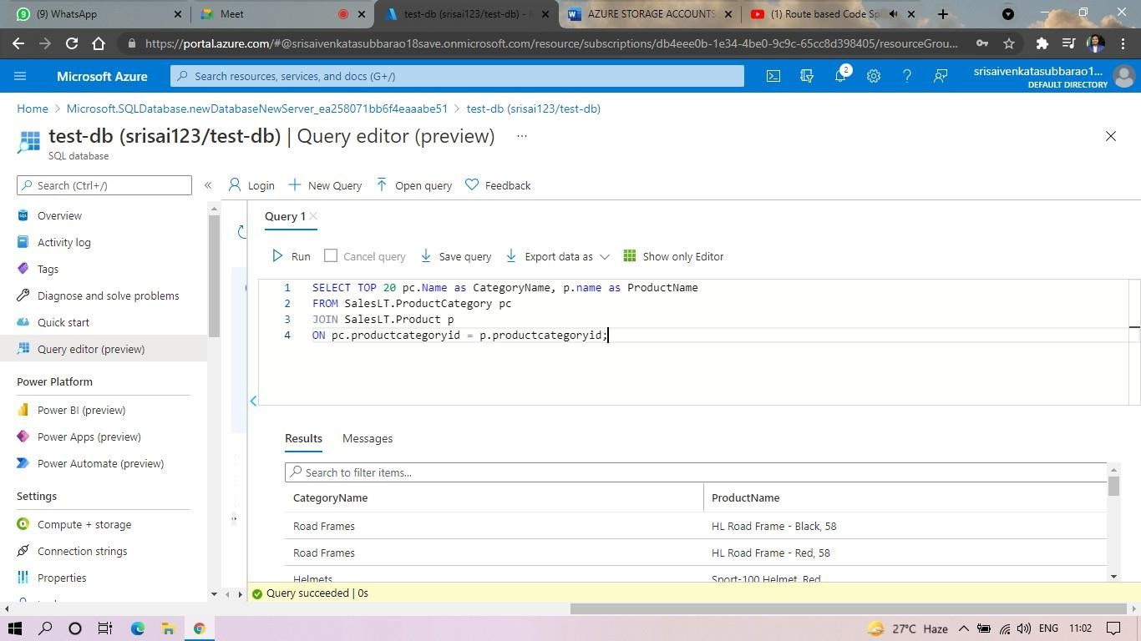

EXP. 22: PERFORM THE BASIC CONFIGURATION SETUP FOR INSTALLINGHADOOP 2.X LIKE CREATING THE HDUSER AND SSH LOCALHOST

**AIM:** PERFORM THE BASIC CONFIGURATION SETUP FOR INSTALLINGHADOOP 2.X LIKE CREATING THE HDUSER AND SSH LOCALHOST

PROCEDURE:

**Step 1** – System Update

$ sudo apt-get update

**Step 2** – Install Java and Set JAVA_HOME

//This first thing to do is to setup the webupd8 ppa on your system. Run the following command and proceed.

$ sudo apt-add-repository ppa:webupd8team/java

$ sudo apt-get update

//After setting up the ppa repository, update the package cache as well.

//Install the Java 8 installer

$ sudo apt-get install oracle-java8-installer

// After the installation is finished, Oracle Java is setup. Run the java command again to check the version and vendor.

[or]

$ sudo apt-get install default-jdk

$ java -version

**Step 3** – Add a dedicated Hadoop user

$ sudo addgroup hadoop

$ sudo adduser --ingroup hadoop hduser

// Add hduser to sudo user group

$ sudo adduser hduser sudo

**Step 4** – Install SSH and Create Certificates

$ sudo apt-get install ssh

$ su hduser

$ ssh-keygen -t rsa -P ""

// Set Environmental variables

$ cat $HOME/.ssh/id_rsa.pub >> $HOME/.ssh/authorized_keys

**Step 5** – Check if SSH works

$ ssh localhost

**Step 6** – Install Hadoop

// Extract Hadoop-2.7.2

$ sudo tar xvzf hadoop-2.7.2.tar.gz

// Create a folder ‘hadoop’ in /usr/local

$ sudo mkdir –p /usr/local/hadoop

// Move the Hadoop folder to /usr/local/hadoop

$ sudo mv hadoop-2.7.2 /usr/local/hadoop

// Assigning read and write access to Hadoop folder

$ sudo chown –R hduser:hadoop /usr/local/hadoop

Implementation:

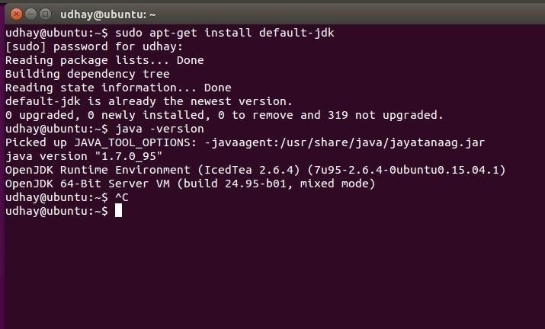

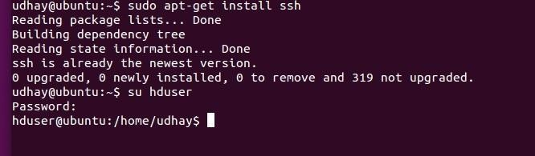

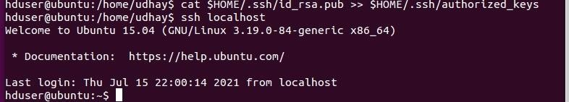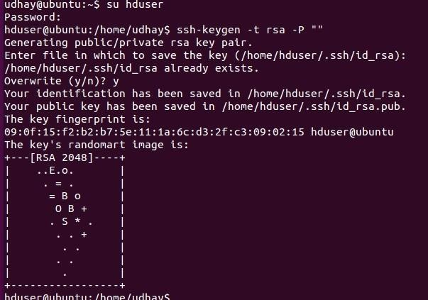

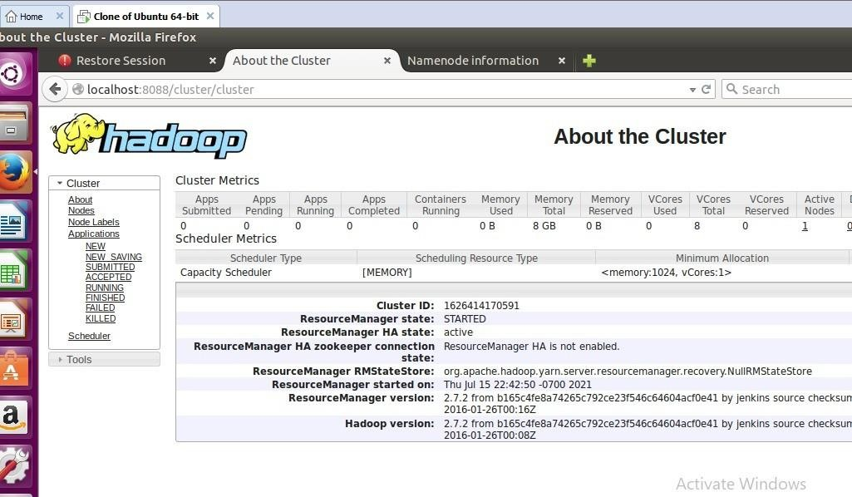

EXP. 23: INSTALL HADOOP 2.X AND CONFIGURE THE NAME NODE AND DATANODE.

**AIM:** INSTALL HADOOP 2.X AND CONFIGURE THE NAME NODE AND DATANODE.

PROCEDURE:

**Step 7** - Modify Hadoop config files

//Hadoop Environmental variable setting – The following files will be modified

1. ~/.bashrc
2. /usr/local/hadoop/hadoop-2.7.2/etc/hadoop/hadoop-env.sh
3. /usr/local/hadoop/hadoop-2.7.2/etc/hadoop/core-site.xml
4. /usr/local/hadoop/hadoop-2.7.2/etc/hadoop/hdfs-site.xml
5. /usr/local/hadoop/hadoop-2.7.2/etc/hadoop/yarn-site.xml
6. /usr/local/hadoop/hadoop-2.7.2/etc/hadoop/mapred-site.xml.template

$ sudo nano ~/.bashrc

// Add the following lines at the end of the file

export JAVA_HOME=/usr/lib/jvm/java-8-oracle

export HADOOP_HOME=/usr/local/hadoop/hadoop-2.7.2 export PATH=$PATH:$HADOOP_HOME/bin

export PATH=$PATH:$HADOOP_HOME/sbin

export HADOOP_MAPRED_HOME=$HADOOP_HOME export HADOOP_COMMON_HOME=$HADOOP_HOME export HADOOP_HDFS_HOME=$HADOOP_HOME

export YARN_HOME=$HADOOP_HOME HADOOP_COMMON_LIB_NATIVE_DIR=$HADOOP_HOME/lib/native export HADOOP_OPTS="-D.java.library.path=$HADOOP_HOME/lib" export PATH=$PATH:/usr/local/hadoop/hadoop-2.7.2/bin

// Configure Hadoop Files

$ cd /usr/local/hadoop/hadoop-2.7.2/etc/hadoop/

$ sudo nano hadoop-env.sh

// Add following line in hadoop-env.sh – Set JAVA variable in Hadoop

# The java implementation to use.

export JAVA_HOME=/usr/lib/jvm/java-8-oracle

// Create datanode and namenode

$ sudo mkdir –p /usr/local/hadoop_tmp/hdfs/namenode

$ sudo mkdir –p /usr/local/hadoop_tmp/hdfs/datanode

// Changing ownership to hadoop_tmp

$ sudo chown –R hduser:hadoop /usr/local/hadoop_tmp

// Edit hdfs-site.xml

$ sudo nano hdfs-site.xml

// Add the following lines between <configuration> …… </configuration>

<configuration>

<property>

<name>dfs.replication</name>

<value>1</value>

</property>

<property>

<name>dfs.namenode.name.dir</name>

<value>file:/usr/local/hadoop_tmp/hdfs/namenode</value>

</property>

<property>

<name>dfs.datanode.data.dir</name>

<value>file:/usr/local/hadoop_tmp/hdfs/datanode</value>

</property>

</configuration>

// Edit core-site.xml

$ sudo nano core-site.xml

// Add the following lines between <configuration> …… </configuration>

<configuration>

<property>

<name>fs.default.name</name>

<value>hdfs://localhost:9000</value>

</property>

</configuration>

// Edit yarn-site.xml

$ sudo nano yarn-site.xml

// Add the following lines between <configuration> …… </configuration>

<configuration>

<property>

<name>yarn.nodemanager.aux-services</name>

<value>mapreduce_shuffle</value>

</property>

<property>

<name>yarn.nodemanager.aux-services.mapreduce.shuffle.class</name>

<value>org.apache.hadoop.mapred.Shuffle-Handler</value>

</property>

</configuration>

// Edit mapred-site.xmsudo

$ cp /usr/local/hadoop/hadoop-2.7.2/etc/hadoop/mapred-site.xml.template

/usr/local/hadoop/hadoop-2.7.2/etc/hadoop/mapred-site.xml

$ sudo nano mapred-site.xml

// Add the following lines between <configuration> …… </configuration>

<configuration>

<property>

<name>mapreduce.framework.name</name>

<value>yarn</value>

</property>

</configuration>

**Step-8** – Format Hadoop File System

$ cd /usr/local/hadoop/hadoop-2.7.2/bin

$ hadoop namenode -format

**Step 9** - Start Hadoop

$ cd /usr/local/hadoop/hadoop-2.7.2/sbin

// Starting dfs services

$ start-dfs.sh

// Starting mapreduce services

$ start-yarn.sh

$ jps

**Step 10** - Check Hadoop through web UI

Go to browser type http://localhost:8088 – All Applications Hadoop Cluster

Go to browser type http://localhost:50070 – Hadoop Namenode

**Step 11** - Stop Hadoop

$ stop-dfs.sh

$ stop-yarn.sh

IMPLEMENTAION:

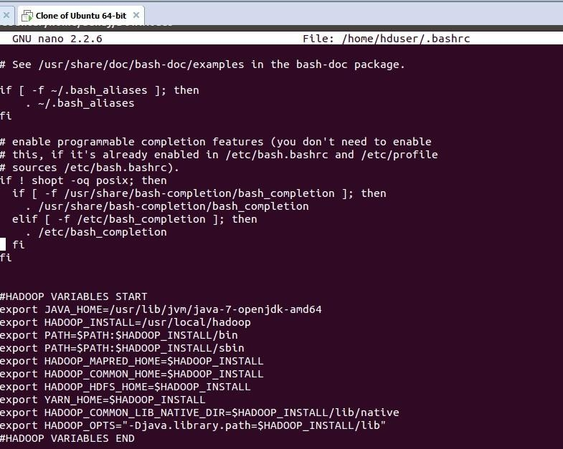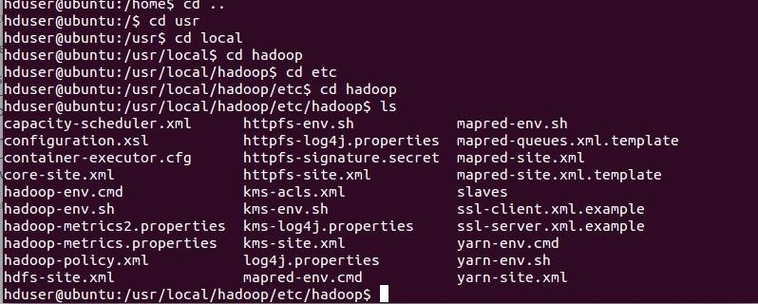

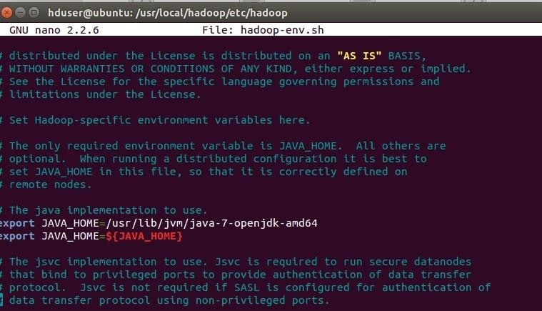

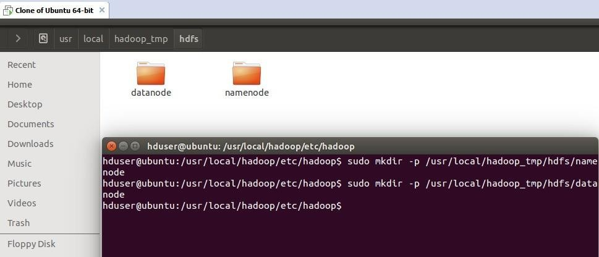

**EXP. 24:** LAUNCH THE HADOOP 2.X AND PERFORM MAPREDUCE PROGRAMFOR A WORD COUNT PROBLEM

**AIM:** LAUNCH THE HADOOP 2.X AND PERFORM MAPREDUCE PROGRAMFOR A WORD COUNT PROBLEM

**PROCEDURE:**

**Step 1 - Open Terminal**

$ su hduser

Password:

**Step 2 - Start dfs and mapreduce services**

$ cd /usr/local/hadoop/hadoop-2.7.2/sbin

$ start-dfs.sh

$ start-yarn.sh

$ jps

**Step 3 - Check Hadoop through web UI**

// Go to browser type http://localhost:8088 – All Applications Hadoop Cluster

// Go to browser type http://localhost:50070 – Hadoop Namenode

**Step 4 – Open New Terminal**

$ cd Desktop/

$ mkdir inputdata

$ cd inputdata/

$ echo “Hai, Hello, How are you? How is your health?” >> hello.txt

$ cat >> hello.txt

**Step 5 – Go back to old Terminal**

$ hadoop fs –copyFromLocal /home/hduser/Desktop/inputdata/hello.txt /folder/hduser

// Check in hello.txt in Namenode using Web UI

**Step 6 – Download and open eclipse by creating workspace**

Create a new java project.

**Step 7 – Add jar to the project**

You need to remove dependencies by adding jar files in the hadoop source folder. Now Clickon

**Project** tab and go to Properties.Under Libraries tab, click Add External JARs and select all the

jars in the folder (click on 1st jar, and Press Shift and Click on last jat to select all jars in between and click ok)

**/usr/local/hadoop/hadoop-2.7.2/share/hadoop/common**and

**/usr/local/hadoop/hadoop-2.7.2/share/hadoop/mapreduce** folders.

**Step -8 – WordCount Program Create 3 java files named**

* **WordCount.java**
* **WordCountMapper.java**
* **WordCountReducer.java WordCount.java**

import org.apache.hadoop.conf.Configured; import org.apache.hadoop.fs.Path;

import org.apache.hadoop.io.IntWritable;

import org.apache.hadoop.mapred.FileInputFormat; import

org.apache.hadoop.mapred.FileOutputFormat;import org.apache.hadoop.mapred.JobClient;

import org.apache.hadoop.mapred.JobConf;

import org.apache.hadoop.util.Tool;

import org.apache.hadoop.util.ToolRunner; import org.apache.hadoop.io.Text;

public class WordCount extends Configured implements Tool {@Override public int run(String[] arg0) throws Exception {

// TODO Auto-generated method stubif(arg0.length<2)

{

System.out.println("check the command line arguments");

}

JobConf conf=new JobConf(WordCount.class);

FileInputFormat.setInputPaths(conf, new Path(arg0[0]));

FileOutputFormat.setOutputPath(conf, new Path(arg0[1])); conf.setMapperClass(WordMapper.class);

conf.setReducerClass(WordReducer.class); conf.setOutputKeyClass(Text.class);

conf.setOutputValueClass(IntWritable.class);

}

}

**WordCountMapper.java**

import java.io.IOException;

import org.apache.hadoop.io.IntWritable; import org.apache.hadoop.io.LongWritable;

import org.apache.hadoop.mapred.MapReduceBase; import org.apache.hadoop.mapred.OutputCollector; import org.apache.hadoop.mapred.Reporter;

import org.apache.hadoop.io.Text;

import org.apache.hadoop.mapred.Mapper;

public class WordCountMapper extends MapReduceBase implements Mapper<LongWritable,Text,Text,IntWritable>

{

@Override

public void map(LongWritable arg0, Text arg1, OutputCollector<Text, IntWritable> arg2, Reporter arg3)

**WordCountReducer.java**

import java.io.IOException;import java.util.Iterator;

import org.apache.hadoop.io.IntWritable; import org.apache.hadoop.mapred.JobConf;

import org.apache.hadoop.mapred.OutputCollector; import org.apache.hadoop.mapred.Reducer;

import org.apache.hadoop.mapred.Reporter; import org.apache.hadoop.io.Text;

public class WordCountReducer implements Reducer<Text,IntWritable,Text,IntWritable> { @Override

public void configure(JobConf arg0) {

}

@Override

public void reduce(Text arg0, Iterator<IntWritable> arg1, OutputCollector<Text, IntWritable> arg2, Reporter arg3)

throws IOException {

// TODO Auto-generated method stubint count=0;

while(arg1.hasNext())

{

IntWritable i=arg1.next(); count+=i.get();

**Step 9 - Creatr JAR file**

Now Click on the Run tab and click Run-Configurations. Click on New Configuration button on the left-top side and Apply after filling the following properties.

**Step 10 - Export JAR file**

Now click on File tab and select Export. under Java, select Runnable Jar.

In Launch Config – select the config fie you created in **Step 9** (WordCountConfig).

Select an export destination (lets say desktop.)

Under Library handling, select Extract Required Libraries into generated JAR and click Finish.

Right-Click the jar file, go to Properties and under **Permissions**tab, Check Allow executingfile as a program. and give Read and Write access to all the users

**Step 11 – Go back to old Terminal for Execution of WordCount Program**

**$hadoop jar** wordcount.jar**/**usr**/**local**/**hadoop**/**input**/**usr**/**local**/**hadoop**/**output

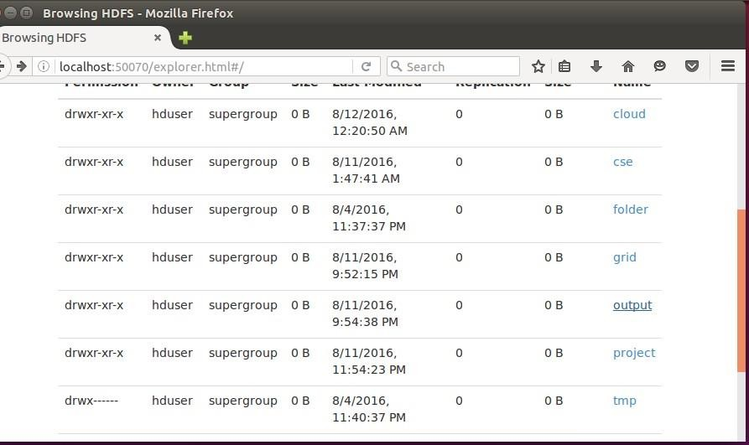

**Step 12 – To view results in old Terminal**

$**hdfs dfs -cat /usr/local/hadoop/output/part-r-00000**

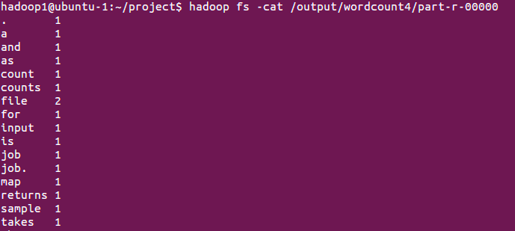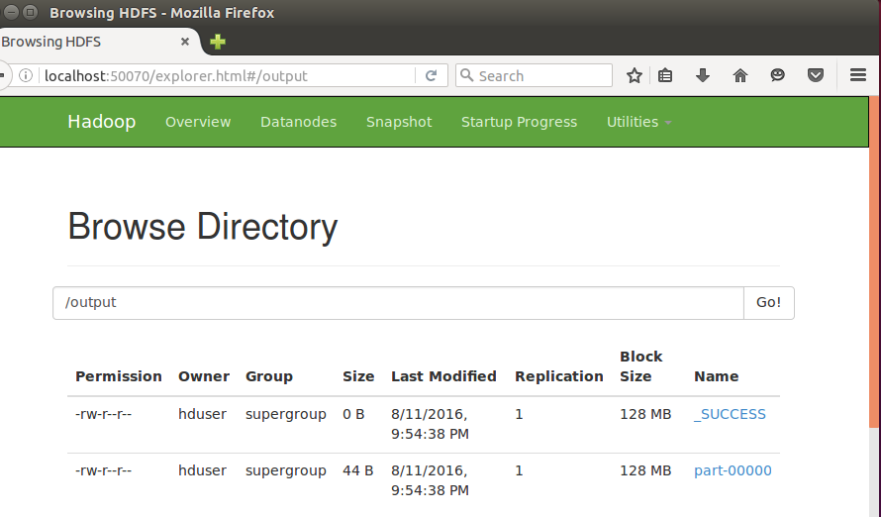

**Step 13 - To Remove folders created using hdfs**

**$ hdfs dfs -rm -R /usr/local/hadoop/output**